Final Report for DUE-1625678
Project DIRACC: Developing and Investigating a Rigorous Approach to Conceptual Calculus
Patrick W. Thompson, PI; Fabio Milner, co-PI, Mark Ashbrook, co-PI
School of Mathematical and Statistical Sciences
Arizona State University

I. Major Goals of the Project 1
I.A. Design and implement DIRACC Calculus 2 as a coherent continuation from DIRACC Calculus 1 1
I.B. Research students’ learning in both the DIRACC and traditional calculus sequences 2
I.C. Develop concept inventories for Calculus 1 and Calculus 2 that other institutions can use to assess students’ progress on central ideas of the calculus 2
II. Year 1 Annual Report 3
II.A. What was accomplished under the project’s goals? 3
II.A.1. Progress on DIRACC Calculus 2 textbook 3
II.A.2. Administered Pre/Post Test to Calculus 1 students 9
II.A.3. Drafted and administered Calculus 1 Concept Inventory 10
II.B. Significant Achievements and Results 11
II.B.1. Calculus 1 pre/post test Results 11
II.B.2. Calculus 1 Concept Inventory (Draft 1) Results 12
II.C. Key outcomes or other achievements 13
II.D. What opportunities for training and professional development has the project provided? 13
II.E. How have results been disseminated to communities of interest? 13
II.F. Plans for Year 2 14
II.F.1. Refine and re-test C1CI 14
II.F.2. Draft and try out C2CI 14
II.F.3. Complete unfinished chapters of Calc II 14
II.F.4. Study students' learning in Calculus 2 15
III. Year 2 Annual Report 16
III.A. What was accomplished under the project’s goals? 16
III.A.1. Updates to DIRACC Calculus 1 chapters 16
III.A.2. Design and implement DIRACC Calculus 2 as a coherent continuation from DIRACC Calculus 1 17
III.A.3. Research students’ learning in both the DIRACC and traditional calculus sequences 17
III.A.4. Refine Calculus 1 Concept Inventory 18
III.A.5. Develop Calculus 2 Concept Inventory 18
III.B. Significant Achievements and Results 19
III.B.1. Calculus 1 Concept Inventory (Draft 2) Results 19
III.B.2. Calculus 2 Concept Inventory (Draft 1) Results 22
III.C. Key outcomes or other achievements 24
III.D. What opportunities for training and professional development has the project provided? 24
III.E. How have results been disseminated to communities of interest? 24
III.F. Plans for Year 3 26
III.F.1. Complete unfinished chapters of Calculus II 26
III.F.2. Refine and re-test C2CI 26
III.F.3. Study students' learning in Calculus 2 26
IV. Year 3 Annual (and Final) Report 27
IV.A. What was accomplished under the project’s goals? 27
IV.A.1. Complete unfinished chapters of Calculus II 27
IV.A.2. Refine and re-test C2CI 27
IV.A.3. Study students' learning in Calculus 2 28
IV.B. Significant Achievements and Results 28
IV.B.1. Refine and re-test the C2CI 28
IV.B.2. Study of Student Learning 33
IV.C. What opportunities for training and professional development has the project provided? 35
IV.D. Key outcomes or other achievements 35
IV.E. How have results been disseminated to communities of interest? 35
IV.E.1. DIRACC Textbook usage at ASU and other sites. 35
IV.E.2. Plans for disseminating Calculus Concept Inventories 36
IV.E.3. Conference Papers and Presentations 36
V. Broader Impact 37
V.A. Impact of DIRACC’s Conceptual Development of Calculus 37
V.B. Impact of Calculus 1 and Calculus 2 concept inventories 37
VI. References 38
VII. Calculus 1 Pre/Post 39
VIII. RMC Research Year 1 Report 42
VIII.A. Pre/Post Test Report 42
VIII.B. C1CI.D1 Report 43
IX. Sample Calculus 1 Concept Inventory Items 49
X. RMC Research Year 2 Report 52
XI. Sample Calculus 2 Concept Inventory Items 57
XII. RMC Research Year 3 Report 60
XIII. DIRACC Calculus 1 Reading Survey (Online) 65
XIV. Interview 2 Protocol 67

Major Goals of the Project

Design and implement DIRACC Calculus 2 as a coherent continuation from DIRACC Calculus 1
DIRACC Calculus 1 covers standard topics in nontraditional ways and in a nontraditional order. It takes as foundational that:
- Variables vary smoothly.
- Differentials are variables. We use the language, “x varies by dx through intervals of length ∆x,” and, “dy varies at a constant rate with respect to dx”.
- Functions are relationships between variables whose values vary.
- Mathematical models arise from conceptualizing situations rigorously in terms of quantities involved and relationships among them.
- Rate of change and accumulation are two sides of a coin. Each can be a foundation for mathematizing the other.
- Integrals are functions that give the exact net accumulation from exact rate of change. Derivatives are functions that give the exact rate of change from variation in exact accumulation functions.
It is important to note that in DIRACC Calculus 1
- Integrals are never proposed as area bounded by the graph of a function.
- Derivatives are never proposed as slope of a line tangent to a curve at a point.
- Approximate accumulation functions are functions.
Traditional calculus emphasizes Riemann sums as approximations to definite integrals. Nothing varies. In DIRACC calculus, every value A(a,x) of an approximate accumulation function A is a Riemann sum. And approximate net accumulation varies as the value of x varies. This is why we call A an approximate net accumulation function.
- Approximate rate of change functions are functions.
Traditional calculus develops the idea of difference quotient as something that approaches the slope of a tangent line as h approaches zero. A difference quotient itself for a particular value of h has no epistemological status. In DIRACC calculus, every value r(x) for a given value of h is a rate of change at a moment for every value of x, one that approximates the accumulation function’s exact rate of change at a moment of x. That is why we call r an approximate rate function.
The challenge for DIRACC Calculus 2 is to reframe standard Calculus 2 topics like
- applications of integrals and derivatives in physical and social sciences,
- areas of regions bounded by curves in rectangular and polar coordinates,
- volume and surface area of solids,
- arc length of functions’ graphs,
- advanced approximation methods for integrals,
- integration techniques,
- sequences and series (including Taylor series), and
- calculus of functions defined parametrically,
in terms of rate of change and accumulation. We address how we have done this in the Accomplishments section of this report.

Research students’ learning in both the DIRACC and traditional calculus sequences
We aimed to investigate students’ learning in DIRACC and traditional calculus using two methods: pre/post testing and individual interviews. The results are reported later in this report, in Accomplishments and Results.

Develop concept inventories for Calculus 1 and Calculus 2 that other institutions can use to assess students’ progress on central ideas of the calculus
Our goal for concept inventories was to develop conceptually valid, psychometrically sound instruments that can be used as assessments of students’ understandings of major ideas of Calculus 1 and Calculus 2, as well as of their gains in the understandings of those major ideas when used as pre/post tests.
We face three major challenges in this quest:
- A major challenge in this regard is to design the instruments so that items assess ideas and not specific curricular treatments of these ideas. It is important that the instruments be accepted as valid in relation to both traditional and DIRACC developments of Calculus 1 and Calculus 2 content.
- A second challenge is that traditional and DIRACC calculus curricula place different emphases on coherence of meanings. For example, traditional Calculus 1 portrays a derivative as a slope of a tangent to a curve and an integral as an area bounded by a function’s graph. Derivatives and integrals are conceptually isolated from each other. DIRACC calculus, in contrast, portrays derivatives as functions whose values give the rate of change at every moment of a varying accumulation, and portrays integrals as functions whose values give net accumulation of a quantity that changes at a given rate of change at every moment. The assessment cannot treat both curricula fairly with regard to connections between derivatives and integrals. To delve into students’ understandings of relationships between derivatives and integrals, for example, will tend to advantage DIRACC students. On the other hand, it might be a useful alert to standard calculus instructors that few of their students see connections between derivatives and integrals.
- There is a third challenge in developing instruments that are fair to both traditional and DIRACC calculus. Traditional treatments of Calculus 1 and Calculus 2 content typically focus on methods for answering questions and not on ways of thinking to understand an idea and connections among ideas across the curriculum. In contrast, having students develop ways of thinking for calculus and to form connections among ideas is a primary goal of DIRACC calculus. DIRACC calculus does not de-emphasize methods; rather, it develops them organically from meanings for central ideas and relationships among these ideas. Nevertheless, a Calculus Concept Inventory must examine the connectedness (coherence) of students’ understandings of calculus ideas.

Year 1 Annual Report

What was accomplished under the project’s goals?

Progress on DIRACC Calculus 2 textbook
We built DIRACC Calculus 2 from DIRACC Calculus 1 by continuing the themes of variables (and differentials) varying, and of accumulation from rate of change and rate of change from accumulation. One important aspect of this continuation is our strong distinction between functions defined in open form and functions defined in closed form.
An accumulation function is defined in open form as an integral, such as
, where
- is the net accumulated change of an (unknown) accumulation function f as its independent variable u varies from u = a to u = t,
- is the exact rate of change function for f, at every moment of f ’s domain,
- du is a variable that varies through intervals of infinitesimal length as u varies through its domain of values.
It is important to keep in mind that in DIRACC Calculus, two quantities vary at a constant rate with respect to each other if and only if their differentials vary proportionally in relation to each other.
DIRACC Calculus 2 emphasizes having students’ model situations with accumulation functions defined in open form. The onus for students using this approach is on determining the quantities that are changing in relation to each other and to determine the rate of change of the accumulating quantity with respect to the other quantity.
It is through our use of technology that having students define accumulation functions in open form ends with their having a usable function. The program Graphing Calculator (GC) allows students to define functions in open form because GC can still compute values of them. This enables a DIRACC instructor to focus students’ attention on what an integral means in relation to the quantitative situation the integral models.
The following descriptions of progress in the DIRACC Calculus textbook are linked to relevant portions of the textbook.

Applications of integrals and derivatives in physical and social sciences
An example of DIRACC approach to problems involving physical quantities:
Modeling the torque exerted by a beam with uniform 0.02 m × 0.05 m cross-section and variable density
kg/m³,
where x is the number of meters from the beam’s fulcrum.
Density is a rate of change of mass with respect to volume. The change of torque with respect to changes in mass, change in mass with respect to changes in volume, and change in volume with respect to x, can be derived by looking at changes in relation to each other:
So the rate of change of torque with respect to distance from the fulcrum is , and accumulated torque as x varies is
This approach to the torque problem entails understanding density as rate of change of mass with respect to volume, and understanding a rectangular cylinder’s volume changing with respect to height at a rate having the same numerical value as the cylinder’s base.
Figure 1 shows the GC implementation of the reasoning given above.
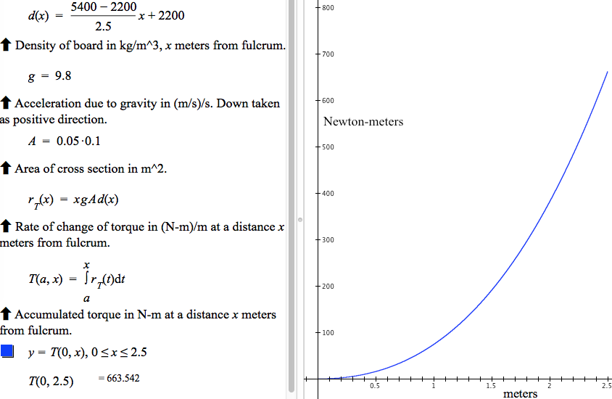
Figure 1. GC file that implements the quantitative reasoning for torque of a variable-density beam.
Figure 1 shows two ways we leverage GC’s capabilities to support student learning in calculus.
- First, it supports students in coming to think of functions defined in open form as legitimate functions. Students are supported in thinking this way because they can use functions defined in open form in the same ways as functions defined in closed form. Students can graph a function defined in open form and compute specific values—just as if the function were defined in closed form.
- Second, the ways we leverage students’ use of GC allows them to see a clear separation between the activity of modeling a situation mathematically and the activity of finding antiderivatives for rate of change functions. Standard approaches to calculus confound the two severely. Students tend to think that finding an antiderivative is part of modeling a situation.
As we explain in Section II.A.1.5, DIRACC Calculus 2 leverages drawbacks in computational meaning of integral (e.g., GC graphs double integrals quite slowly). This motivates finding closed form equivalents of open form integrals in order to make computations more efficient.

Areas of regions bounded by curves in rectangular and polar coordinates
Rectangular Coordinates. DIRACC Calculus 2 develops the idea of net signed area. Let A be the area of a rectangle of constant height h cm and varying width w cm. The rate of change of A with respect to w is h cm²/cm. This is the foundation for net signed area of a region bounded by a graph in rectangular coordinates.
A rectangle with height f(x) has rate of change of area with respect to width that is numerically equal to f(x). That is, . The differential in area A(x) of a rectangle that has height f(x) is dA = f(x)dx. Therefore, net signed area of a region in rectangular coordinates bounded by the graphs of y = 0, x = a, and y = f(x) is
Polar Coordinates. The rate of change of area of a circular region of radius r with respect to θ is r²/2. Therefore, in polar coordinates, the rate of change of area of a region bounded by the graphs of θ = 0 and r = f(θ) is .
The rate of change is not a signed rate because f(θ)² is always non-negative. The rate of change of signed area with respect to θ is better defined as . Net signed area of a region in polar coordinates bounded by the graph of θ = 0 and r = f(θ) is therefore
In developing net signed area of regions bounded by graphs, we show that the standard topic of area of regions bounded by curves in Cartesian and polar coordinates can be developed coherently with the ideas of accumulation functions from rate of change functions. Signed area is just one application of integrals as accumulation functions.

Volume of solids
The DIRACC approach to the calculus of solids is grounded in two ideas:
- Think of a solid’s surface as being a shell. Rotating a graph around an axis or sliding a cross section along an axis creates a shell that we will fill to quantify its volume.
- Quantify the solid’s volume by thinking of filling the shell with cylinders that vary infinitesimally in one of two ways: (a) the cylinders have constant base and varying height, or (b) they have constant height and varying radius (or cross-section).
The benefit of 1) to students is twofold:
- It separates the actions of defining the solid from computing its volume,
- It separates the idea of the original function’s independent variable from the idea of the accumulating volume’s independent variable, They need not be the same.
The benefit of 2) to students is it removes the confusion that students often experience as to which “method” they should use (or are using)—shells, slabs, disks or washers. They are all cylinders. The crucial difference is in how the cylinders vary to fill the shell, and that choice is dictated by their choice of independent variable for the accumulating volume.
If a cylinder has constant base and varying height, the volume’s rate of change with respect to height is the area of the base. If a cylinder has constant height and varying radius, its rate of change of volume with respect to radius is the cylinder’s outer surface area, which is perimeter times height.
Expressed in integral form for circular cylinders,
We expressed the above in terms of the variable u because u can have values on either the x- or y-axis depending on how you parameterize the shell and the way you situate your cylinders.

Arc length of functions’ graphs and surface area of solids
Arc length ds of a function f ’s graph as dx varies is . Therefore, and accumulated arc length over an interval from a to x is
Surface area of solids of revolution can be approximated with cones. We develop the conclusion that the rate of change of area of a cone’s frustum is . Accumulated surface area S(a,x) over an interval [a,x] is, therefore,
.

Integration techniques
The chapter on integration techniques is still in draft form, existing at the moment only in the form of Keynote presentations and student handouts.
DIRACC Calculus 2 sets the stage for integration techniques in the section on applications of integrals in the physical and social sciences. Several examples and problems involve rate of change functions that are themselves defined as integrals (e.g., determining a distance traveled when only the object’s acceleration is given). Velocity is the rate of change of displacement with respect to time, but velocity is defined as an accumulation from acceleration.
GC computes double integrals very inefficiently. GC takes a long time to graph a function that involves a double integral because it computes the value of one integral at each value of an integral that defines one value of the second integral.
We use the example of slow graphing to point out that integrals defined in closed form are computed far more efficiently than integrals defined in open form. This observation motivates the quest for developing techniques for finding antiderivatives of rate of change functions. The FTC is invoked repeatedly in making this connection.

Advanced approximation methods for integrals
DIRACC Calculus 2 motivates advanced approximation techniques in two ways:
- By noting (in lay terms) that the class of functions that have closed form antiderivatives has measure zero in the class of integrable functions defined over the real numbers. In other words, many functions students will meet outside of calculus class cannot be integrated using antiderivative techniques they learned.
- By continuing the theme of accumulation from rate of change, but making ever stronger assumptions about orders of rate of change of accumulation functions that are essentially constant over infinitesimal intervals.
  - Assuming the first-order rate of change of accumulation is essentially constant over infinitesimal intervals leads to what are customarily called Riemann approximations to the exact accumulation (“rectangle quadrature rule”), which are developed in DIRACC Calculus 1.
  - Assuming the second-order rate of change of accumulation is essentially constant over infinitesimal intervals leads to linear approximations of the rate of change function. This is customarily called the trapezoidal method for approximating exact accumulation (“trapezoidal quadrature rule”).
  - Assuming the third-order rate of change of accumulation is essentially constant over infinitesimal intervals leads to quadratic approximations of the rate of change function. This is customarily called Simpson’s method for approximating exact accumulation (“Simpson’s quadrature rule”).
We compare the three methods in terms of maximum absolute approximation error over an interval. As describe in Section II.A.1.7, we then leverage this idea of bounds on approximation error to raise the idea of convergence of sequences of function values at specific values of an independent variable and over intervals of an independent variable.

Sequences and series (including Taylor series)
The section on the general idea of sequences and series is only partially developed, with the majority of it available only in the form of Keynote presentations and student handouts.
DIRACC Calculus 2 leverages sequences of approximate accumulation functions to address the idea of convergence at a value in the function’s domain and convergence over an interval of the function’s domain.
Convergence. We do not use Weirstrass’ notion of convergence to a number L. Instead, we use Gauss’ notion of convergence that does not presume a limit. We speak of convergence as being able to always find a place in a sequence so that no two terms after that place are farther apart than a level of tolerance we set.
While we do not develop a formal distinction between pointwise and uniform convergence of a sequence of functions, we do raise the issue of whether an approximation that is “good enough” at one value in an accumulation function’s domain is “good enough” for all values in an interval of the function’s domain. We have students explore under what conditions you can predict the latter. Our intent is that students discover that the latter happens when the accumulation function’s rate of change function is bounded over the interval.
Polynomial approximations and Taylor series. DIRACC’s development of approximation techniques, based on ever stronger assumptions about n^{th}-order rate of change functions of an accumulation function being constant, generalizes naturally and easily to the idea of polynomial approximations and Taylor series.
The section on polynomial approximations and Taylor series exists, at the moment of this report, largely in the form of Keynote presentations and student activity sheets.

Calculus of functions defined parametrically
The section on functions defined parametrically is the only part of the textbook that has not been tried or drafted. We have several ideas about ways to develop this content that are potentially coherent with the chapters preceding it. We will settle on an approach in Fall 2017. A basic concept to start the description is the realization that, even though great many curves in the Cartesian plane are not the graphs of functions, they all are graphs of parametrized functions (since, for example, their Cartesian x- and y-coordinates can be parametrized by arclength).

Administered Pre/Post Test to Calculus 1 students
The pretest (Appendix ASU-A1) was constructed in Summer 2015 by a group of Calculus 1 instructors (2 traditional, 2 DIRACC) and the Director of STEM programs for the School of Mathematical and Statistical Sciences (SoMSS). Each question in the final version received unanimous support among the 5 participants that the question assessed an important idea that students in their courses should understand, and the instrument itself received unanimous support that it covered most of the ideas in Calculus 1.
The pretest was administered to 1044 students: 768 in Engineering Calculus 1 (ENG) and 276 in DIRACC Calculus 1 (DIR). Contrary to plan, traditional Calculus 1 instructors did not administer the pretest.
The same test was given as a posttest near the end of Fall 2016 semester to ENG and DIR Calculus 1 students. DIR instructors included the posttest in their final exam. However, ENG calculus instructors declined to include the posttest in their final exam. We therefore recruited engineering students to take the posttest outside of class. Ninety-nine (99) ENG students sat for the posttest. Only 72 of them had taken the pretest. We report only on students who took both pretest and posttest in Results.
RMC Research analyzed psychometric properties of Calculus 1 pre/post test. Their analyses are reported in Appendix RMC-A1. The DIRACC team will revise the pre/post test in light of RMC’s analyses. We discuss this further in Plans for Coming Year.

Drafted and administered Calculus 1 Concept Inventory
We constructed the Calculus 1 Concept Inventory (C1CI) with a focus on students’ understandings of central ideas of the calculus. It is not a skills test.
The C1CI major item categories and number of items in them for the pilot are:
- Variation and covariation (2)
- Function (10)
- Rate of change (12)
- Accumulation (6)
- Modeling/Quantitative Reasoning (3)
- Fundamental Theorem of Calculus (5)
- Structure sense (5)
We based these item categories on research literature and our own experience dealing with students’ difficulties in Calculus 1. Results of administering the C2CI.D1 are in Section II.B.2.

Method of constructing C1CI Items
After deciding the major item categories the DIRACC team employed a grounded approach to drafting items. Candidate items were put forward, typically drawn from research reports and from tests, quizzes, or student activity worksheets that members had created. The group discussed each candidate item in terms of meanings and ways of thinking the item might assess.
We created lists of questions we had about particular items in relation to the thinking they might prompt in students. As the question lists grew, research assistants scheduled interviews with students recruited from current Calculus 1 and Calculus 2 courses. RAs interviewed 16 students in Fall 2016 and 25 students in Spring 2017. Items were then revised, replaced, or discarded according to what we learned from student interviews. We also sent draft items to RMC Research for their feedback regarding item design and potential problems with gender or cultural biases.
The final draft of C1CI (43 items) was administered to 164 students in March 2017: 76 in Calculus 1 and 88 in Calculus 2.
We recruited students by announcing the C1CI in all ASU and Chandler-Gilbert CC Calculus 1 and Calculus 2 classes. We included Calculus 2 students because we intend the C1CI to be used as both pretest and posttest for Calculus 1.
Students then volunteered by supplying their contact information at a specially designed website. Students who took the C1CI received a $30 cash payment.
We are in the process of analyzing actual response patterns to each of the 43 items. RMC Research analyzed psychometric properties of C1CI items. Their analyses are reported in Appendix RMC-A1. The DIRACC team will revise the pre/post test in light of its content analysis of students’ responses and in light of RMC’s Rasch analyses. We discuss this further in Plans for Coming Year.

Significant Achievements and Results

Calculus 1 pre/post test Results
Because Engineering (ENG) instructors declined to include the posttest within their final exam we recruited ENG students to take the posttest outside of class. Of 99 volunteers, 72 had taken the pretest. Table 1 shows that the 72 ENG students who took both pretest and posttest were representative of all ENG students who took the pretest. The two groups had essentially identical means and standard deviations.
Table 1. Comparison of Engineering students who took pre/post test and pre-test only. Pre/Post-test ENG students were representative of Pretest Only ENG based on pretest scores
Group | Count | Pretest Mean | StdDev
ENG Pre/Post | 72 | 2.99 | 1.45
ENG Pre Only | 696 | 3.00 | 1.54
Table 2 shows that ENG and DIRACC (DIR) students who took both pretest and posttest were not similar in pretest scores. ENG students had a pretest mean of 2.99; DIR students had a pretest mean of 3.99. We have no explanation for the initial disparity between ENG and DIRACC students. Table 2 shows pretest and posttest results for ENG and DIR Calculus 1 students.

Table 2, Pretest and Posttest results for Engineering (ENG) and DIRACC (DIR) Calculus 1 students.
Group | Count | Pre-µ | Pre-SD | Post-µ | Post-SD
ENG | 72 | 2.99 | 1.45 | 4.38 | 2.04
DIR | 206 | 3.71 | 1.44 | 7.13 | 2.02
We compared ENG and DIR gain scores because of the difference in pretest scores. Table 3 shows a significant difference in mean gain scores favoring DIR students.
Table 3. Comparison of Engineering (ENG) and DIRACC (DIR) gain scores from Pretest to Posttest.
Group | Count | Mean Gain | StdDev | t-test
ENG | 72 | 1.39 | 2.34 | t = 20.17
DIR | 206 | 3.41 | 2.18 | p < 0.0001
It is interesting to note that 21% of ENG students had a negative gain score, whereas 4% of DIR students had a negative gain score.

Calculus 1 Concept Inventory (Draft 1) Results
We administered the C1CI.D1 to 164 Calculus 1 and Calculus 2 students (Table 4). We did not track whether students were in Engineering, Traditional, or DIRACC calculus because comparing these approaches was not an aim of the testing.
Table 4. C1CI.D1 results (possible highest score of 43).
Group | Count | Mean | StdDev
Calc I | 76 | 14.49 | 7.35
Calc II | 88 | 16.30 | 5.77
Calculus 2 students scored slightly higher than Calculus 1 students, but not substantially higher. Also, scores were slightly skewed left (Figure 2). Four students highlighted in Figure 2 are outliers: two were enrolled in Calculus 1 and two were enrolled in Calculus 2.
The lack of substantial difference between Calculus 1 and Calculus 2 students is striking. Calculus 1 students were half way through their course. Calculus 2 students were half way through their course, and presumably had completed Calculus 1 in a recent semester. We think this is worthy of further study but at this moment are unsure of how to pursue the reason for this lack of difference. One possible reason is that Calculus 2 students in traditional settings for both Calculus 1 and II may be unable to develop more meaningful concepts for accumulation and rate of change but rather just improve computational skills.
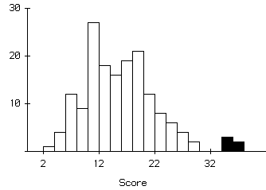
Figure 2. Histogram of C1CI scores.
An analysis by gender shows a difference between males and females, with males scoring slightly higher than females (Table 5). We will examine each item for significant gender bias.
Table 5. C1CI Results by Gender.
Group | Count | Mean | StdDev
Female | 64 | 14.63 | 5.96
Male | 99 | 16.05 | 6.96
Other | 1 | 10 | •
RMC’s Rasch analysis (Appendix RMC-D) showed that several items did not differentiate well between high and low scorers, especially items related to the Fundamental Theorem of Calculus. We will examine these items in our Fall 2017 revision of the C1CI.

Key outcomes or other achievements
Nothing more to report than reported above in Achievements and Significant Results

What opportunities for training and professional development has the project provided?
- Three RAs participated in design and validation of C1CI items.
- Two SoMSS Lecturers taught large-lecture sections of DIRACC Calculus 1 and participated in discussions of refining the textbook.
- Five TAs participated in implementing DIRACC Calculus 1
- One TA participated in exploratory design experiment of DIRACC Calculus 2
- One professor of mathematics at Portland State University participated in week-long DIRACC professional development

How have results been disseminated to communities of interest?
- David Bressoud's Launchings
David Bressoud featured DIRACC Calculus 1 in his May and June issues of his MAA blog Launchings.
- DIRACC textbook made available on internet
The current (and continually updated) DIRACC Calculus textbook is available online to anyone wishing to explore it or use it. As one person commented, we are “blogging” our textbook.
- DIRACC project page opened at Researchgate
We opened a project site at Researchgate. This site contains a description of Project DIRACC and a link to the DIRACC Calculus textbook. It also contains publications related to Project DIRACC.
- Portland State University is doing a trial implementation of portions of DIRACC Calculus 1
Dr. Ann Sitimor of Portland State University Department of Mathematics participated in the Project’s three-day summer workshop on teaching DIRACC calculus. Colleagues of Dr. Sitomor at Portland State are reviewing DIRACC Calculus 1 for possible inclusion in their revised calculus.

Plans for Year 2

Refine and re-test C1CI
We will revise the Calculus 1 Concept Inventory based upon the psychometric analyses conducted by RMC Research and upon feedback from the Project DIRACC advisory board.

Draft and try out C2CI
Following a similar approach to that used for the development of the C1CI, we will begin by identifying several domains of content that are key to conceptual understandings in Calculus 2. Then, we will produce a set of items in each domain that will be presented to Calculus 2 students during interviews in order to elucidate some of their understandings and misconceptions in the various domains.

Complete unfinished chapters of Calc II
During the first semester of Year 2 (that is by the end of 2017) we plan to produce working drafts of the missing chapters (Integration Techniques, Sequences and Series, and Functions Defined Parametrically) and make them available in the DIRACC calculus textbook as soon as they are produced.

Integration techniques
The desirability/need of integration techniques that expand the classes of functions that have antiderivatives available in closed form has already been established by the much faster computation of accumulation functions in closed form as compared to those in open form. Integration by parts, for example, will be naturally motivated by its connection to the idea of accumulation of the rate of change function of a product function through the “product rule”.

Polar coordinates
We will further develop and expand the chapter in the DIRACC calculus textbook covering calculus in polar coordinates (Chapter 11). At present, it has draft materials only in its introduction (Section 11.0) and for the computation of signed areas as accumulation functions in polar coordinates (Section 11.3). However, it needs all materials for Graphs in Polar Coordinates and Their Properties (Section 11.1) and for Coordinate Conversions (Section 11.2). We will provide many examples for section 11.1 that result in graphs with multiple lines of symmetry and relate this property to the periodicity of the trigonometric functions that define polar coordinates.

Parametric functions
We will begin from the basic idea that in a functional relation there are two co-varying quantities, one of which we choose to call “the independent variable” making the other “the dependent variable”. Then we will present the natural generalization that, once we choose an independent variable (to be called the parameter), we may have any number of dependent variables, each co-varying with the parameter. Thus, by choosing two such variables, x and y say, co-varying with the parameter, t say, their graph on the Cartesian xy-plane is now a (planar) curve without restrictions on repeated values because the parameter is invisible in that graph. The simplest of parametrizations is, of course, x = t, y = f(t) for any function f. Its graph is just the graph of f over the chosen domain for the independent variable (i.e. the parameter) x. If we choose three such variables, say x, y and z, co-varying with the parameter t, their graph on the Cartesian xyz-space is now a (spatial) curve in three-dimensional space, again without restrictions on repeated values because the parameter is invisible in that graph. We will then move on to the computation of rates of change functions for parametric functions using compositions and implicitly defined functions when needed.

Study students' learning in Calculus 2
Just as we did for first-semester calculus, we will investigate students’ learning in DIRACC and traditional second-semester calculus using two methods: pre/post testing and individual interviews. Once the C2CI items have been developed, we will offer them to students in Calculus 2, both at ASU and in Community Colleges, both in traditional and revised sections. In spring 2018 we will also administer some of the items in the C2CI as a pre/post test to investigate students’ gains in conceptual understandings of key calculus 2 ideas.

Year 2 Annual Report

What was accomplished under the project’s goals?

Updates to DIRACC Calculus 1 chapters
A number of improvements were made to Chapters 1-4 (precalculus concepts) and Chapters 5-7 (accumulation from rate, rate from accumulation, applications of derivatives).
- “Change” versus “vary”. We discovered that we (and standard textbooks) used the word “change” ambiguously. We used it with three different meanings: change in progress, completed change, or become something different. Students mostly understood “change” to mean become something different, which interfered with their understanding our major use of “change” as change in progress.
We therefore made the following substitutions throughout the textbook to clarify our meaning for students. We used “vary” when we meant change in progress, “variation” when we meant completed change, and “change” when we meant become something different. The one exception was the phrase “rate of change”, which we retained because of its universal usage. However, we now state repeatedly, and exemplify through animations, that “change” in “rate of change” refers to change in progress.
- Smooth variation. We always had the tacit image in crafting the textbook’s prose that variables’ values vary smoothly. However, students often missed this nuance, retaining their primary image that variables’ values vary discretely or in solid chunks. We refined and added to the textbook’s prose, and added student activities, to orient students to envision variables’ values varying smoothly. For example, we unpacked the phrase “the value of x changes …” to say “the value of x varies by dx through intervals of length ∆x” and developed animations and reflection questions to help students build imagistic understandings of it.
- Constant rate of change. Students often had impoverished meanings of constant rate of change, due largely to the way they thought of change. Their discrete or chunky images of ways variables’ values vary kept them from envisioning constant rate of change as entailing a variable’s value varying through tiny intervals so that approximate variation is modeled by the relationship dy = m dx. We added one new section on more and less productive ways of understanding constant rate of change, and inserted activities that we hope gives students opportunities to employ productive ways of thinking that entail smooth variation within constant rate of change.
- Online homework. In summer 2017 we put chapter exercises and reflection questions for Chapters 1-4 into the iMathAS homework system. In summer 2018 we put chapter exercises and reflection questions for Chapter 5-7 into the iMathAS homework system. Having homework online reduces the amount of work required of instructors and teaching assistants and gives students feedback on their work much sooner than when homework is hand-graded.

Design and implement DIRACC Calculus 2 as a coherent continuation from DIRACC Calculus 1
- Refined Chapter 8 (applications of integrals).
- Draft of Chapter 9 (integration techniques) to be completed Summer 2018. Emphasis is on leveraging structure sense in “undoing a derivative”. Motivation builds from Chapter 8 in terms of computational efficiency of functions defined in closed form.
- Revised Chapter 10 (sequences and series). Expanded motivation—functions having a closed-form antiderivative has measure zero in the space of integrable functions. Developed Taylor polynomials (approximation at a value) within the theme of making stronger assumptions about rate of change of accumulation. Still to be expanded: pointwise and uniform convergence.
- Draft of Chapter 11 (relationships defined parametrically) developed within a theme of covariation of quantities. Completed Fall 2017. Still to be expanded: calculus of relationships defined parametrically.
- Split polar coordinates from Chapter 8, making it a stand-alone chapter. Completed Fall 2017.

Research students’ learning in both the DIRACC and traditional calculus sequences
As stated in our Year 1 report, we made a pre/post comparison of traditional and DIRACC students’ understandings of central calculus ideas in Fall 2016 using a test that was constructed by a committee of Calculus 1 instructors from all programs. We did this prior to NSF funding. We also published research articles delving into sources of conceptual difficulties with concepts of function and rate of change (Byerley & Thompson, 2017; Thompson, Hatfield, Yoon, Joshua, & Byerley, 2017; Thompson & Milner, 2019).
Our intention for Year 2 was to make a pre/post comparison of students’ learning in Calculus 2 using selected items from the Calculus 2 Concept Inventory (C2CI). Unfortunately, because of our Fall 2017 focus on revising and re-testing the C1CI (reported in Section III.A.3 and III.B.1) we could not follow this plan. We were unable to begin the first draft of the C2CI before the beginning of Spring 2018 semester.
As an alternative to pre/post comparisons of students’ learning in Calculus 2, we collected program information from students volunteering to take the C2CI in April, 2018. Results are reported in Section III.B.2. Section III.F contains our Year 3 plan for pre/post comparisons of students’ learning in traditional and DIRACC Calculus 2 and expanded plan for gathering qualitative data regarding students’ understandings of major ideas in the Calculus 2 curriculum.

Refine Calculus 1 Concept Inventory
As reported in Year 1, we administered Draft 1 of the Calculus 1 Concept Inventory (C1CI.D1) in March 2017 to 164 students. We reviewed items in Summer and Fall 2017 from three perspectives: (1) item performance in Rasch analysis performed by RMC Research, (2) item content in light of item performance, and (3) students’ selections among alternatives. We refined the wording of several items and modified or replaced alternatives that students rarely chose. Modifications were tested in item interviews of students enrolled in Calculus 1 or Calculus 2: 12 student interviews on 25 items and item revisions.
We administered the C1CI.D2 in November 2017 to 225 students. To entice a larger number of students, we increased the average stipend to $50. Our announcement stated that each student would receive $40 cash for taking the C1CI.D2 and that students with scores in the top 50% would receive a $20 bonus. Three hundred thirty-one (331) students registered to take the C1CI.D2; 225 students actually took it. Performance results and breakdowns of students by characteristics are given in Section III.B.1.

Develop Calculus 2 Concept Inventory
Constructing a Calculus 2 Concept Inventory proved a challenge. The traditional content of Calculus 2 is focused on procedures – finding antiderivatives, computing areas, volumes, and arc lengths, converting from Cartesian to polar coordinates, and so on. In DIRACC, each topic fits within the overall framework that all of calculus addresses two issues:
- You know how fast a quantity varies at every moment; you want to know how much of it there is at every moment.
- You know how much of a quantity there is at every moment; you want to know how fast it varies at every moment.
For example, traditional treatments of computing volumes of solids give little attention to ways to conceptualize solids in terms of variables whose values vary, and therefore little attention to volume as a function whose value varies. The idea of function is ancillary. The focus is on setting up a definite integral for computing the volume of a fixed solid, then finding an antiderivative and evaluating it at two numbers. Accumulation of volume (and hence rate of change of volume) with respect to an independent variable is not addressed.
In DIRACC, students are supported to conceive of volumes of solids within the overall theme of accumulation from rate of change. You quantify volume by filling a region bound by a shell with cylinders having a known rate of change of volume with respect to radius or height. A concept inventory that probes students’ conceptualization of volume as a function of another variable could easily favor students in a DIRACC curriculum.
With this constraint in mind, we strived to develop an instrument that would not advantage students in a DIRACC curriculum yet still address fundamental concepts underlying the Calculus 2 curriculum. We were somewhat unsatisfied with procedural overtone of many items even before we gave it to students. But our self-imposed constraint forced us in that direction.

Method of constructing C2CI Items
Our method of constructing the C2CI paralleled our development of the C1CI. After deciding the major item categories the DIRACC team employed a grounded approach to drafting items.
The C2CI major item categories and number of items in them for Draft 1 were:
- Geometry applications (6 items)
- Improper integrals (1 item)
- Integration techniques (6 items)
- Functions defined parametrically (4 items)
- Physical applications (5 items)
- Polar coordinates (3 items)
- Sequences and series (7 items)
We based these item categories on research literature and our own experience dealing with students’ difficulties in Calculus 2. Results of administering the C2CI.D1 are in Section III.B.2.
Candidate items were put forward, typically drawn from research reports and from tests, quizzes, or student activity worksheets that members had created. We discussed each candidate item in terms of meanings and ways of thinking the item might assess.
We created lists of questions we had about particular items in relation to the thinking they might prompt in students. As the question lists grew, research assistants scheduled interviews with students recruited from current Calculus 2 and Calculus 3 courses. Research Assistants interviewed 11 students on 31 candidate items and their revisions. Items were then revised, replaced, or discarded according to what we learned from student interviews. We also sent draft items to RMC Research for their feedback regarding item design and potential problems with gender or cultural biases.
The final draft of C2CI.D1 (32 items) was administered to 134 students in April, 2018. We recruited students by announcing the C2CI in all ASU sections of Calculus 2 and Calculus 3.
RMC Research analyzed psychometric properties of C2CI.D1 items. Their analyses are reported in Appendix RMC-A2. Among their recommendations were to add 10 items and add easier items, especially in Physical Applications and Polar Coordinates.
We are in the process of analyzing actual response patterns to each of the 32 items. The DIRACC team will revise the pre/post test in light of its content analysis of students’ responses and in light of RMC’s Rasch analyses. We discuss this further in Plans for Coming Year.

Significant Achievements and Results

Calculus 1 Concept Inventory (Draft 2) Results
We administered the C1CI.D2 to 158 Calculus 1 and 67 Calculus 2 students (total 225 students) in November, 2017. Table 6 shows a breakdown of students by program and course. Table 7 shows a breakdown of students by gender and course. Table 8 shows a breakdown of students by gender and program.
Table 6. C1CI.D2 breakdown of students by program and course
 | Calc 1 | Calc 2 | total
DIRACC | 15 | 8 | 23
TRAD | 19 | 6 | 25
ENG | 124 | 53 | 177
total | 158 | 67 | 225

Table 7. C1CI.D2 breakdown of students by gender and course
 | Calc 1 | Calc 2 | total
Female | 55 | 19 | 74
Male | 98 | 46 | 144
Other | 2 | 0 | 2
Decline | 3 | 2 | 5
total | 158 | 67 | 225

Table 8. C1CI.D2 breakdown of students by gender and program
 | DIRACC | TRAD | ENG | total
Female | 5 | 7 | 62 | 74
Male | 17 | 18 | 109 | 144
Other | 1 | 0 | 1 | 2
Decline | 0 | 0 | 5 | 5
total | 23 | 25 | 177 | 225
The histogram in Figure 3 shows the overall distribution of C1CI.D2 scores. They ranged from a low of 3 to a high of 41 (of 43 possible).
Figure 3. Distribution of student scores on C1CI.D2 (43 possible)
RMC Research recommended that we give the C1CI as untimed and record the duration between students’ check-in and check-out times. Figure 4 presents a scatterplot of times (in minutes) in relation to students’ total scores. There is a significant positive relationship between the two (Pearson r = 0.53, p < 0.0001).
Figure 4. Time (minutes) versus total score on C1CI.D2 (r = 0.53)
Table 9 shows scores by gender. There is no essential difference among students declaring Female, Male, or Other. We have no explanation why students who declined to answer might have scored lower than students who declared gender, but they are so few we did not test for significance.
Table 9. C1CI.D2 means and standard deviations by gender
 | Count | Mean | StdDev
Female | 74 | 18.74 | 7.26
Male | 144 | 19.47 | 8.10
Other | 2 | 18.50 | 4.95
Decline | 5 | 12.40 | 5.41
Table 10 shows results within construct categories by program. Students in DIRACC and Traditional calculus were very close; students in Engineering, as in all other testing, scored lower than students in DIRACC and Traditional calculus.
Table 10. C1CI.D2 Results by program
 | n | VAR | FUN | SS | MQR | ROC | ACC | FTC | Total
DIRACC | 23 | 1.83 | 5.09 | 3.61 | 3.57 | 3.22 | 2.48 | 1.96 | 21.74
TRAD | 25 | 1.92 | 4.40 | 3.64 | 3.60 | 2.52 | 2.64 | 2.08 | 20.80
ENG | 177 | 1.76 | 4.08 | 3.37 | 3.22 | 2.31 | 2.15 | 1.58 | 18.47
possible |  | 4 | 9 | 6 | 6 | 7 | 6 | 5 | 43

There was a small but significant difference between students in Calculus 1 and students in Calculus 2 (t = 2.98, p < 0.0032).
Table 11. C1CI.D2 Results by students' course
 | n | VAR | FUN | SS | MQR | ROC | ACC | FTC | Total
Calc 1 | 158 | 1.69 | 4.03 | 3.26 | 3.16 | 2.24 | 2.16 | 1.54 | 18.08
Calc 2 | 67 | 2.01 | 4.67 | 3.82 | 3.63 | 2.85 | 2.42 | 2.00 | 21.40
possible |  | 4 | 9 | 6 | 6 | 7 | 6 | 5 | 43

Calculus 2 Concept Inventory (Draft 1) Results
We cannot report student breakdown by gender because we forgot to include a question about gender.
We provide several statistical comparisons (with p-values) in the remaining discussion. We caution that the students in this administration of the C2CI.D1 were not selected randomly, so comparisons might reflect uncontrolled biases among students who chose to take the C2CI.D1.
Table 12 presents a breakdown of students taking the C2CI.D1 according to their course and program.
Table 12. C2CI.D1 of students breakdown by program and course
 | Calc 2 | Calc 3 | total
DIRACC | 19 | 8 | 27
TRAD | 16 | 11 | 27
ENG | 67 | 13 | 80
total | 102 | 32 | 134
Figure 5 presents a histogram of scores. The distribution is skewed left with μ=9.93 and median=9.

Figure 5. Distribution of C2CI.D1 scores (32 possible).
μ=9.93, median=9, s.d.=4.30, min=1, max=24
As suggested by RMC Research, we recorded the time a student arrived and the time the student submitted his or her answer sheet. Figure 6 shows a scatterplot of total scores versus number of minutes between arriving and departing. There is a significant linear relationship between score and time, although when ignoring the seven students taking the most time this relationship becomes non-significant.
Figure 6. Time (minutes) versus score on C2CI.D1 (r = 0.40)
Table 13 presents average scores by construct and program. An ANOVA shows significant differences among programs (F = 9.90, d.f.=2).
Table 13. C2CI.D1 results by program
 | n | GEO | IMP | INT | PF | PHS | POL | SEQ | Total
DIRACC | 27 | 2.19 | 0.33 | 2.67 | 1.93 | 1.74 | 1.00 | 2.89 | 12.74
TRAD | 27 | 2.07 | 0.15 | 2.22 | 1.52 | 1.41 | 0.70 | 2.41 | 10.48
ENG | 80 | 1.40 | 0.14 | 2.10 | 1.54 | 1.15 | 0.84 | 1.66 | 8.80
possible |  | 6 | 1 | 6 | 4 | 5 | 3 | 7 | 32
Table 14 presents Scheffe comparisons of total scores by program. DIRACC scores were significantly higher than ENG scores and moderately higher than TRAD scores. TRAD scores were moderately higher than ENG scores.
Table 14. Scheffe comparisons of total score among programs.
 | Difference | Std Error | p-value
DIRACC-ENG | 3.94 | 0.90 | 0.001
DIRACC-TRAD | 2.26 | 1.10 | 0.13
TRAD-ENG | 1.68 | 0.90 | 0.18
Table 15 presents comparisons within constructs between students enrolled in Calculus 2 and students enrolled in Calculus 3. Calculus 3 students’ average score in each construct was slightly higher with the exception of the 1-item category of Improper Integrals. Calculus 3 students’ average total score was moderately higher than that of Calculus 2 students (t = 1.67, p < 0.10).
Table 15. C2CI.D1 results by students' course (for Total: t = 1.67, p < 0.10)
 | n | GEO | IMP | INT | PF | PHS | POL | SEQ | Total
Calc 2 | 102 | 1.61 | 0.19 | 2.16 | 1.58 | 1.26 | 0.79 | 2.02 | 9.59
Calc 3 | 32 | 1.97 | 0.16 | 2.50 | 1.72 | 1.50 | 1.00 | 2.19 | 11.03
possible |  | 6 | 1 | 6 | 4 | 5 | 3 | 7 | 32

Key outcomes or other achievements
Nothing not already reported in III.B, Significant Achievements.

What opportunities for training and professional development has the project provided?
- Two RAs participated in the modification of C1CI items and in the design and validation of C2CI items.
- Two SoMSS Lecturers taught large-lecture sections of DIRACC Calculus 1 and participated in discussions of refining the textbook. One SoMSS Lecturer taught a large-lecture section of DIRACC Calculus 2.
- Seven TAs participated in implementing DIRACC Calculus 1 or Calculus 2.
- Five Ph.D. students participated in a seminar entitled Epistemology and Technology of Learning and Teaching Calculus.
- One professor of mathematics and two teaching assistants at Portland State University taught DIRACC Calculus 1 or Calculus 2.

How have results been disseminated to communities of interest?
- News article in Research Features
Project DIRACC collaborated with Research Features of the United Kingdom to produce a news article highlighting the unique contributions of Project DIRACC to calculus reform.
- DIRACC textbook made available on internet
The current (and continually updated) DIRACC Calculus textbook is available online to anyone wishing to explore it or use it. As one person commented, we are “blogging” our textbook.
Figure 7 provides data from Statcounter on user access to the textbook. It shows 27,104 page views by 8,132 unique visitors between September, 2017 and December 31, 2017 and 40,063 page views by 11,308 unique visitors between January 1, 2018 and June 30, 2018. Each section in the book (e.g., Chapter 10, Section 10.1) is one web page.
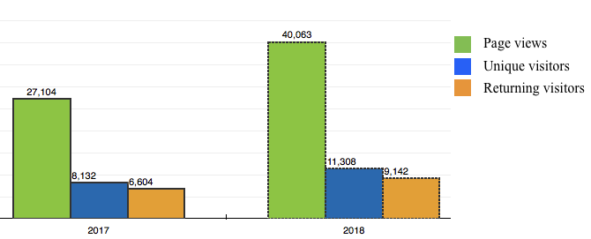
Figure 7. Statcounter data on visits to DIRACC textbook for Sep-Dec 2017 and Jan-Jun 2018.
There were approximately 420 DIRACC students in Fall 2017 and 440 DIRACC students in Spring 2018. Assuming each student accessed the DIRACC textbook from 3 different computers, they would be recorded as 1260 unique visitors in Fall 2017 and 1320 unique visitors in Spring 2018. The remaining visits are by visitors outside the DIRACC student community.
Ninety-five percent (95%) of visitors came from the U.S. This means there were approximately 400 unique non-US visitors in Fall 2017 and 560 unique non-US visitors in Spring 2018.
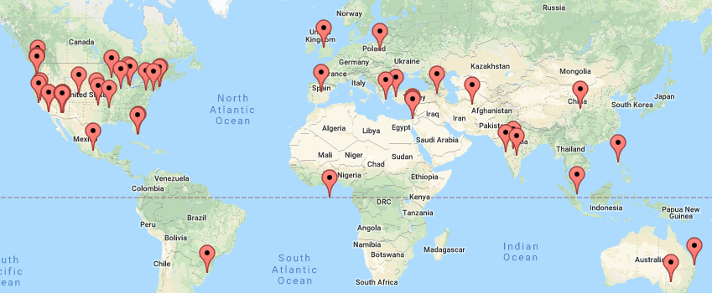
Figure 8. Map of visitors to DIRACC textbook from September 2017 to June 2018.
- DIRACC project page at Researchgate
We opened a project site at Researchgate in January 2017. This site contains a description of Project DIRACC and a link to the DIRACC Calculus textbook. It also contains publications related to Project DIRACC. As of July 1, 2018 the project was accessed by 408 people and had 32 followers.
- Portland State University conducts a trial implementation of DIRACC Calculus 1 and Calculus 2.
Dr. Ann Sitimor and colleagues at Portland State University are using the DIRACC textbook in Calculus 1 and Calculus 2. They are using Desmos instead of Graphing Calculator. They are also following a traditional order of derivatives before integrals because PSU is on a quarter system and derivatives and integrals are in separate courses.

Plans for Year 3

Complete unfinished chapters of Calculus II
The textbook has a number of loose ends in several chapters, especially Chapters 9 (integration techniques), 10 (pointwise and uniform convergence), 11 (calculus in polar coordinates), and 12 (calculus of relationships defined parametrically). We will also put homework for Chapters 8-12 online, in iMathAS.

Refine and re-test C2CI
We are working on recommendations from RMC Research regarding the C2CI.D1, specifically adding easier items to the physical applications and polar coordinates categories and reducing the number of items in Sequences and Series. We are also examining students’ actual selections for each item’s alternative answers with the aim of replacing alternatives rarely selected by students.
We will administer the C2CI.D2 in November of 2018 to 250 Calculus 2 and Calculus 3 students, drawn from DIRACC, traditional, and engineering programs.

Study students' learning in Calculus 2
The DIRACC team, in collaboration with instructors from traditional and engineering programs, will use the same methodology as for constructing the Calculus 1 pre/post test to construct a Calculus 2 pre/post test to be given to all students in each program. We can say “all students” because we have secured the cooperation of the director of STEM programs to conduct this comparison.
We will augment the pre/post comparison with a qualitative investigation of students’ understandings of central concepts of the Calculus 2 curriculum. The first round of student interviews will start with questions on the Calculus 2 pre/post test. Subsequent rounds of interviews will be predicated on our analyses of students’ understandings from the first round. The first round of interviews will involve 5 students from each program selected to provide a range of understandings as suggested by students’ pretest answers. Subsequent rounds will expand the pool from the original 15 students to include an additional 5 students from each program.
We will use the qualitative interview data in two ways. First, we will use it to enhance our interpretations of test data collected from all students. We intend to publish about these results. Second, we will write articles about students’ meanings and ways of thinking about ideas in Calculus 2. We anticipate these articles will be published separately from articles about the aggregate data, although there will certainly be an overlap between articles about aggregate results and articles about students’ qualitative understandings.

Year 3 Annual (and Final) Report

What was accomplished under the project’s goals?

Complete unfinished chapters of Calculus II
We planned to complete several chapters in Year 3, especially Chapters 9 (integration techniques), 10 (pointwise and uniform convergence), 11 (calculus in polar coordinates), and 12 (calculus of relationships defined parametrically) and to put homework for Chapters 8-12 online, in iMathAS. Chapter 9 is now in PDF format, but we have yet to encode it in html. Our focus on refining and retesting the C2CI and on studying students’ learning absorbed most available resources, so the completion of Chapters 10, 11, and 12 were postponed for the 2019-2020 school year.

Refine and re-test C2CI
In Fall 2018 the DIRACC team revised the C2CI with RMC Research’s recommendations in mind. RMC Research made several recommendations regarding the C2CI.D1—add easier items to the physical applications and polar coordinates categories and reduce the number of items in Sequences and Series. We also examined students’ actual selections for each item’s alternative answers with the aim of replacing alternatives rarely selected by students. RMC also suggested eliminating some mis-fitting items (according to Rasch measures), but they and we agreed to leave them in for the second testing before eliminating them.
In revising the C2CI.D1 we
- Reviewed optional answers for each item and concluded that no changes were needed
- Moved the item from the one-item scale of Improper Integrals to Integration Techniques and added one new item (for a total of 8 items)
- Added one item to Parametric Functions (for a total of 5 items)
- Added two items we hoped would be “easy” to Physical Applications (for a total of 7 items)
- Added four items we hoped would be “easy” to Polar Coordinates (for a total of 7 items)
- Left Sequences and Series unchanged (7 items)
- Left Geometric Applications unchanged (6 items)
for a total of 40 items.
We administered the C2CI.D2 in April 2019 to 254 students—151 students in Calculus 2 and 103 students in Calculus 3. Analyses of the C2CI.D2 are in IV.B. Significant Achievements and Results.

Study students' learning in Calculus 2
We intended to collaborate with instructors from traditional and engineering programs to construct a Calculus 2 pre/post test to be given to all students in each program and to follow up this comparison with a qualitative investigation of students’ understandings of central concepts of the Calculus 2 curriculum. Supplemental funding was sufficient only to support one graduate student (and no faculty), so we decided to focus on the qualitative investigation of student learning.
We could not study students’ learning in traditional math/science Calculus 2 because only DIRACC sections were offered in Spring 2019. The PI organized a group of interested math education Ph.D. students to investigate effects on students’ practices and interpretations of the textbook of their meanings for ideas-to-be-presented. We used the Fall semester to train students on interviewing techniques centered around students’ interpretations of key passages and animations in the DIRACC textbook and to develop protocols for interviews in Spring 2019. More about this study is in IV.B. Significant Achievements and Results.

Significant Achievements and Results

Refine and re-test the C2CI

C2CI.D2 Results
In Fall 2018 the DIRACC team revised the C2CI.D1 with RMC Research’s recommendations in mind. RMC suggested adding easier items to Physical Applications and Polar Coordinates. We (RMC and ASU) decided to keep items in Sequences and Series in the second administration even though there were too many to include in the final version. Appendix XI contains sample items from the C2CI.D2.
We recruited students in March 2019 by sending personal invitation emails to all students enrolled in Calculus 2 and Calculus 3 at all four campuses of ASU. The email explained the purpose and background of the C2CI and offered a payment of $50 for taking the C2CI.D2 plus a bonus of $20 to students scoring in the top 50%. Table 16 shows numbers of invited students in each program. We were unable to distinguish between DIRACC and Traditional sections of calculus because the student data provided us for inviting students did not distinguish between them.
Table 16. Students invited to take C2CI.D2
Course | # Students Invited | # Responses | # Attended
Engin Calc 2 | 1392 | 134 | 114
Engin Calc 3 | 943 | 93 | 79
Math/Sci Calc 2 | 196 | 47 | 37
Math/Sci Calc 3 | 116 | 26 | 24
Table 17 shows the distribution among programs of students actually taking the C2CI.D2. The DIRACC entry under Calculus 3 is zero because DIRACC does not have Calculus 3. Eight (8) of the 24 students enrolled in Traditional Calculus 3 took one or more of DIRACC Calculus 1 or 2.
Table 17. Distribution of C2CI.D2 students among programs
Program | Enrolled in Calculus 2 | Enrolled in Calculus 3
Engineering | 114 | 79
DIRACC | 18 | 0
Traditional | 19 | 24
Total | 151 | 103
Figure 9 shows distributions of scores, ranging from 3 to 31 (out of 40). The test was difficult for students (mean of 12.5) across all six constructs (more on this later).
Figure 9. Histogram of total scores. n = 254; µ = 12.5; sd = 4.81.
On advice from RMC Research, the test was untimed and records of arrival and departure allowed us to record the number of minutes each student was in the testing room. Figure 10 shows a scatterplot of total score versus time on test. It shows some students spent very little time (less than 30 minutes). Overall Pearson r is 0.395. When we restrict data to 30 to 70 minutes on the test (to get a sense of effect of a time limitation and omitting students who may not have tried their best), Pearson r is 0.305.

Figure 10. Scatterplot of Total Score by Time on Test. Pearson r = 0.395. Pearson r restricted to 30 - 70 min = 0.305.
Table 18 gives a breakdown by gender and group of performance on the C2CI.D2. Female scores were consistently lower than males, especially in Traditional Calc 3. We have no explanation for this. We attended to potential gender bias as best we could. It is worth noting that while the PI and co-PIs were male, all graduate students were female. It is part of the culture in ASU math education that students speak freely in meetings without concern.
Table 18. Breakdown of gender by group, with means and standard deviations.
 | Male | Female | Decline/Other
DIR Calc 2 | 9 (µ = 15 sd = 4) | 8 (µ = 14 sd = 3.3) | 1
ENG Calc 2 | 82 (µ = 11.6 sd = 4) | 31 (µ = 10.6 sd = 3.8) | 1
ENG Calc 3 | 50 (µ = 12.6 sd = 5.1) | 29 (µ = 11.7 sd = 3.3)
Trad Calc 2 | 10 (µ = 13.7 sd = 4.5) | 9 (µ = 12.4 sd = 3.8)
Trad Calc 3 | 12 (µ = 18.5 sd = 8.2) | 12 (µ = 15.8 sd = 6.5)
Overall performance by students in programs and courses is given in Table 19. Traditional Calculus 3 students scored highest, followed by DIRACC Calculus 2, Traditional Calculus 2. Engineering Calculus 3, then Engineering Calculus 2. We do not make probabilistic comparisons among the group scores because of the small numbers of DIRACC and Traditional students and because students volunteered to take the C2CI.D2.
Table 19. Overall performance on C2CI.D2 by subgroup (possible score: 40)
 | Count | Mean | StdDev
DIRACC Calc 2 | 18 | 14.50 | 3.50
Engin Calc 2 | 114 | 11.32 | 3.96
Engin Calc 3 | 79 | 12.27 | 4.49
Trad Calc 2 | 19 | 13.11 | 4.09
Trad Calc 3 | 24 | 17.17 | 7.34
Group ranks in Table 19 is consistent with pre/post results for Calculus 1, two results from the C1CI, and results from the C2CI.D1. DIRACC students scored highest and Engineering students scored lowest among DIRACC, Traditional, and Engineering. We hasten to point out that the pretest/posttest, C1CI, and C2CI were painstakingly constructed to avoid favoring students in the DIRACC curriculum. We asked the advisory board to be especially alert for instances of potential favor in their reviews of instrument drafts.
Table 20 shows student performance within constructs of the C2CI. We find it remarkable that DIRACC students scored as high as they did on Integration Techniques (INT), Parametric Functions (PF) and Polar Coordinates (POL). Integration techniques receive diminished attention in DIRACC Calculus 2. Also, by the time of testing, their instructor had given just one introductory lesson on parametric functions and had not begun polar coordinates. On the other hand, we are puzzled by DIRACC Calculus 2 students’ poor performance on Physical Applications. We gave considerable emphasis to conceptualizing situations quantitatively and modeling quantitative relationships mathematically.
Table 20. C2CI.D2 results within constructs by students' program and course
 | n | GEO | INT | PF | PHS | POL | SEQ
DIRACC Calc 2 | 18 | µ=1.9 sd=1.1 | µ=3.2 sd=1.1 | µ=2.3 sd=1 | µ=1.7 sd=1.2 | µ=2.6 sd=1.2 | µ=2.7 sd=1.4
Engin Calc 2 | 114 | µ=1.5 sd=1.0 | µ=2.4 sd=1.5 | µ=1.4 sd=1 | µ=1.8 sd=1.3 | µ=2.5 sd=1.2 | µ=1.8 sd=1.2
Engin Calc 3 | 79 | µ=1.5 sd=1.2 | µ=2.6 sd=1.4 | µ=1.6 sd=1.1 | µ=1.8 sd=1.2 | µ=3 sd=1.4 | µ=1.7 sd=1
Trad Calc 2 | 19 | µ=1.7 sd=0.9 | µ=2.4 sd=1.9 | µ=1.9 sd=1.1 | µ=1.8 sd=1.5 | µ=2.6 sd=1.6 | µ=2.7 sd=1.2
Trad Calc 3 | 24 | µ=2.5 sd=1.7 | µ=3.6 sd=2 | µ=2.5 sd=1.3 | µ=2 sd=1.4 | µ=4.1 sd=1.6 | µ=2.5 sd=1.4
Possible |  | 6 | 8 | 5 | 7 | 7 | 7

Difficulty of C2CI Items
Table 20 shows the relatively poor performance of all subgroups (including DIRACC) within each construct of the C2CI. This could be, in principle, for one or more of four reasons:
- The test’s items are unreasonably demanding in terms of sophisticated understanding,
- The test’s items validly assess conceptual understanding, but students’ orientations to mathematical learning during instruction had little to do with understanding.
- Calculus instructors could have held a calculational orientation even as they envisioned themselves teaching for conceptual understanding (Thompson, Philipp, Thompson, & Boyd, 1994),
- Calculus instructors could have taught with a conceptual orientation, but were unaware of how dramatically students’ strong calculational orientation affected what they understood instructors were saying (Thompson, 2013).
We are unconvinced that items in the C2CI are unreasonably demanding from the point of view of what students should understand from Calculus 2. We base this claim on two sources: (a) Feedback from the DIRACC Advisory Board, and (b) A prior project (Project Aspire, NSF Grant No. MSP-1050595) to assess U.S. high school teachers’ mathematical meanings for teaching secondary mathematics.
Regarding (a), the DIRACC Advisory Board reviewed items and agreed that they addressed important and reasonable understandings students should have. Regarding (b), early feedback in the development of Project Aspire’s assessment instrument was that its items expressed unreasonable expectations of meanings teachers should have for the mathematics they teach. However, the same instrument translated to Korean showed South Korean middle and high school teachers met these expectations to a far higher degree than U.S. teachers (Thompson, 2015; Thompson, et al., 2017; Thompson & Milner, 2019; Yoon, Byerley, & Thompson, 2015). We therefore suspect Reasons 2-4 to be more centrally at play than Reason 1. Section IV.B.2 Study of Student Learning addresses this more fully.

Comments on C2CI.D2 by RMC Research
RMC Research performed a Rasch analysis of the C2CI.D2 (Appendix XII). The analysis pointed to several issues with psychometric properties of the instrument:
- Person fit for Physical Applications and Polar Coordinates, measured as 0.00 for the C2CI.D1, remained at 0.00 for the C2CI.D2. As RMC Research notes in their report (Appendix XII), this indicates that items in these domains do a poor job of distinguishing between high and low scorers in these domains.
Possible reasons are small variation in students’ responses (in this case, high item difficulty) or rampant guessing (related to item difficulty). If either is the case, we thought we would find higher person separation and higher person reliability for Calculus 3 students. We therefore asked RMC Research to re-analyze the data for Physical Applications and Polar Coordinates for Calculus 2 and Calculus 3 students separately. Results were the same for both groups as originally. To understand this result requires further research.
- RMC Research found four (4) misfitting items—all in Polar Coordinates. Item fit statistics indicate how well item responses fit the model and are reflective of the underlying construct. Items may misfit because of multidimensionality (they are measuring a different construct), keystroke error during the data entry process, or poor item quality (e.g., unclear wording, unclear response options).
When items misfit, you then examine them to see if you can identify why. Are they measuring a different aspect of the construct than the rest of the items? Were they worded in a way that was confusing to students – both the stem and/or the response options? Were there data entry errors in the file?
We found no issues of data entry or unclear wording, so we will drop these items from the instrument for the meantime and revisit what students’ responses to them suggest about the items. We think they are good items—probing students’ understandings of polar coordinates or the calculus of functions represented in polar coordinates.

Study of Student Learning
We asked 94 DIRACC Calculus 1 students at the end of Spring 2018 semester to choose how strongly they agreed or disagreed with the following statement:
I prefer textbooks that focus on showing me what to do and giving me practice doing it.
Seventy-seven (77) of 94 students (81.9%) somewhat agreed or strongly agreed with the statement. Their collective answer to this statement was in line with other data that relatively few students read the DIRACC textbook regularly. Students not reading the textbook also stated they were not learning from the textbook (which they did not read). We suspected there were hidden factors behind their feelings about the textbook and uses of it that are related to our hypotheses in Section IV.B.1.2 (Difficulty of C2CI Items).
The DIRACC PI formed a group of mathematics education PhD students to investigate the impact students’ mathematical meanings and meanings for “understanding” had on their reading practices and on their understandings of ideas expressed in the DIRACC textbook. The group, formed in Fall 2018, spent fall semester reviewing literature on students’ reading of mathematical texts. Group members also practiced interview techniques and practiced creating interview protocols.
In January 2019 we surveyed DIRACC Calculus 1 students to learn about their prior mathematical reading practices and textbook usage (the survey is in Section XIII). We classified students as Low, Medium, or High on each of two uses of textbooks: reading practices and preparation for tests. We selected 5 students from each of three cells along the diagonal—Low on reading practice, Low on preparation for tests, etc.). We were aware these classifications were based on students’ self-reports when creating categories of Low, Medium, and High.
Interview 1 was in the 3rd week of class, Interview 2 was in the 7th week of class, and Interview 3 was in the 12th week of class. Students were paid $50 per interview. Each interview started by asking students their understanding of key terms and phrases. Then students read passages and watched animations from content they had covered. The rest of each interview had students read passages and watch animations from content they would cover soon. The protocol for Interview 2 is in Section XIV.
In April 2019, students in DIRACC Calculus 1 responded to a version of the first survey, modified for use at the course’s end. All students also responded to a “meanings quiz” that asked them to explain their meaning of key terms and phrases that recurred throughout the course.
The study produced an immense amount of data which we are analyzing for publication. Several themes stand out even in our early analyses:
- Many students experience animations through experiential time. That is, they think that when the value of x varies, it varies with respect to time. Evidence of this is:
  - The common description of the value of x varying “at some rate” and the value of y varying “at another rate”, each rate having nothing to do with the other.
  - The common interpretation of an animation showing the value of x varying on the x-axis as being the graph of a function.
  - In an animation of a cylinder with constant base and varying height, the height varies at different rates with respect to time. Many students insist that the rate of change of volume with respect to height is not constant, “Because it speeds up and slows down”.
- Many students do not conceive of variables covarying. When they imagine quantities covarying they look to the interior of a quadrant in a coordinate system without thinking explicitly that any point goes with a value of y (on the y-axis) and a value of x (on the x-axis). It is more like they envision a graph as a wire and a point moving on it as if a bead on a wire.
- Many students tend to watch animations as if they are watching television. They do not read the surrounding explanations spontaneously, nor do they reflect on mathematical meanings the animation might emphasize.
- Function notation remains problematic for students even after intense instructional attention. Many students hold the notion that f(x) does not represent a function’s value in relation to a value of x until you have a defining rule on the other side of an equal sign.
- Many students conceive graphs with at most gross covariation – instead of thinking the graph is composed of points (x, f(x)) as the value of x varies, they think of gross variations in variables’ values (“y goes up as x increases, then it goes down”).
- Many students read symbolic statements mnemonically (the whole statement reminds them of what they think it means) or literally, such as reading “ ” as “f-of-x-plus-h-minus-f-of-x-divided-by-x-plus-h-minus-x” instead of meaningfully, as in “the relative size of the change in f and the change in x”, or even “the average rate of change of f over the interval [x, x+h]”.
- Many students choose not to read the textbook, relying instead on lectures (or video recordings of lectures) and then going straight to the online homework. The relationship between these students’ mathematical meanings and ways of thinking and their textbook usage is unclear. They might have weak meanings because they avoid reading the textbook, or when they read the textbook it is without the aim of understanding. Or, they might avoid the textbook because their meanings are too weak to read it profitably. We hope this becomes clearer with closer analysis of the data.

What opportunities for training and professional development has the project provided?
- One RA participated in the modification and validation of C2CI items.
- Two SoMSS Lecturers and one Ph.D. student taught large-lecture sections of DIRACC Calculus 1 and participated in discussions of refining the textbook. One SoMSS Lecturer taught a large-lecture section of DIRACC Calculus 2.
- Seven TAs participated in implementing DIRACC Calculus 1 or Calculus 2.
- Five TAs participated in a year-long, semi-weekly seminar on crafting productive interactions with students in recitation sessions.
- One professor of mathematics and two teaching assistants at Portland State University taught modified versions of DIRACC Calculus 1 or Calculus 2.
- Twenty-two community college instructors agreed to implement DIRACC calculus in a proposed scale-up project.
We have a better understanding that instructors must be aware of these issues. We suspect many of them persist because instructors are unaware they exist. This will be an important theme in future professional development.

Key outcomes or other achievements
Nothing not already reported in Sections IV.A and IV.B.

How have results been disseminated to communities of interest?

DIRACC Textbook usage at ASU and other sites.
Figure 11 shows textbook usage for Fall 2018 and Spring/Summer. 2019. A page view means someone viewed one section of the textbook – each section is one web page. A visitor is counted as unique only on his or her first visit to the DIRACC website. A returning visitor is someone who visits the website (any page) more than once. We cannot provide a map of visitors’ locations. That functionality in Statcounter is not working at this time.
Assuming DIRACC students accessed the textbook from two different computers each, they accounted for 700 unique or returning visitors in Aug 1 – Dec 31, 2018 and 640 unique or returning visitors in Jan 1 – Jul 31, 2019. All other visitors are people not in a DIRACC course.
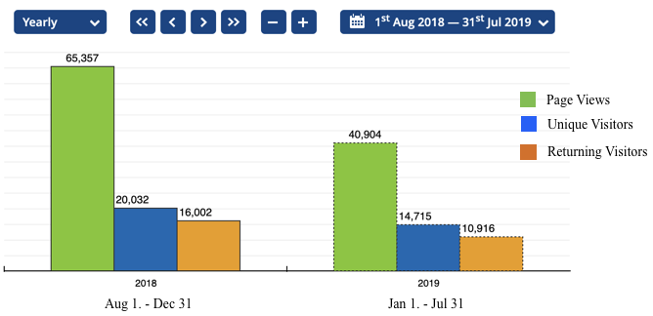
Figure 11. StatCounter Data for Access to DIRACC Textbook

Plans for disseminating Calculus Concept Inventories
We are negotiating with ASU that they manage access to the C1CI and C2CI. When these arrangements are finalized we will announce their availability in the College Math Journal and the Mathematics Magazine of the MAA.
One change we will make is that we will break both the C1CI and C2CI into construct packets. This way users can download only the parts appropriate for their use, along with detailed statistics by item we gathered for that construct.

Conference Papers and Presentations

- Ashbrook, M. (2019, May) DIRACC Calculus at Arizona State University: A Brief Tour. Seminal / Progress Though Calculus Conference, Lincoln, NE
- Milner, Fabio A. (2019, January) Project DIRACC: Developing and Investigating a Rigorous Approach to Conceptual Calculus, JMM NSF/DUE Poster Session, Baltimore, MD.
- Milner, Fabio A. (2019, May) Precalculus/Calculus Pathways at Arizona State University, Seminal / Progress Though Calculus Conference, Lincoln, NE.
- Milner, Fabio A. (2019, August) Change in Modality of Calculus Teaching at ASU: A Return to Historical Roots and Divorce from Mathematical Analysis, University of Sonora, Hermosillo, Mexico.
- Thompson, P. W. (2019, May) Developing and Investigating a Rigorous Approach to Conceptual Calculus. Distinguished lecture at California Polytechnic University, Pomona, Pomona, CA.
- Thompson, P. W. (2019, August) Making the Fundamental Theorem of Calculus Fundamental to Students’ Calculus. Plenary presentation at the International Conference on Calculus in Upper Secondary and Beginning University Mathematics, University of Adger, Kristiansand, Norway

Broader Impact

Project DIRACC’s impact is in two areas:
- Impact of DIRACC curricular approach to conceptual development for ideas of calculus
- Impact of Calculus 1 and Calculus 2 concept inventories

Impact of DIRACC’s Conceptual Development of Calculus
At ASU, DIRACC calculus is the standard curriculum for mathematics and science majors, with occasional exceptions due to unavailability of instructors familiar with DIRACC.
Locally, the ASU team is working with colleges in the Maricopa County Community College system to align calculus taught in the MCCC system and DIRACC math/science calculus at ASU.
The DIRACC curriculum is discussed widely in national and international circles. The PI regularly receives emails from people attending conferences of the Mathematical Association of America, American Mathematical Association of Two Year Colleges; Congress of the European Society for Research in Mathematics Education, International Group for the Psychology of Mathematics Education, and the MAA Special Interest Group for Research in Undergraduate Mathematics Education who heard about DIRACC and wish to learn more. The PI was invited to an international conference in Norway to speak about the DIRACC curriculum—its motive, design, and impact on student learning.
Regarding DIRACC’s impact on curricular efforts, Steve Boyce (Portland State University) is adapting portions of the DIRACC curriculum under its Creative Commons license for use in the Knewton calculus curriculum. The Israeli high school curriculum committee included variation, covariation, and accumulation functions as key concepts in its new 5-point high school mathematics curriculum as a result of members learning of the PI’s research and the DIRACC curriculum.

Impact of Calculus 1 and Calculus 2 concept inventories
The DIRACC Calculus Concept Inventories have had both a national and international impact. Texas A & M University received an NSF grant to build from the C1CI (and other instruments) to create an assessment that can be used as both a pretest and a posttest. The C1CI is used most appropriately as an end-of-semester assessment. A working group of the MAA Special Interest Group for Research in Undergraduate Mathematics is also using the C1CI in its effort to assess students’ understanding of core concepts of calculus. Finally, The Israel Science Foundation funded a grant led by Tommy Dreyfus in which the DIRACC C1CI is mentioned specifically in terms of its methodology and as inspiration for a high school calculus concept inventory. The PI is a consultant on the Dreyfus grant.

References

Byerley, C., & Thompson, P. W. (2017). Secondary teachers' meanings for measure, slope, and rate of change. Journal of Mathematical Behavior, 48, 168-193.
Thompson, A. G., Philipp, R. A., Thompson, P. W., & Boyd, B. A. (1994). Calculational and conceptual orientations in teaching mathematics. In A. Coxford (Ed.), 1994 Yearbook of the NCTM (pp. 79–92). Reston, VA: NCTM.
Thompson, P. W. (2013). In the absence of meaning. In K. Leatham (Ed.), Vital directions for research in mathematics education (pp. 57-93). New York: Springer.
Thompson, P. W. (2015). Mathematical meanings of Korean and USA mathematics teachers for mathematical ideas they teach. In O. N. Kwon (Ed.), Proceedings of the Korean Society of Mathematics Education International Conference on Mathematics Education, pp. 1-6). Seoul, Korea: Seoul National University.
Thompson, P. W., Hatfield, N. J., Yoon, H., Joshua, S., & Byerley, C. (2017). Covariational reasoning among U.S. and South Korean secondary mathematics teachers. Journal of Mathematical Behavior, 48, 95-111. doi: 10.1016/j.jmathb.2017.08.001
Thompson, P. W., & Milner, F. A. (2019). Teachers’ meanings for function and function notation in South Korea and the United States. In H.-G. Weigand, W. McCallum, M. Menghini, M. Neubrand & G. Schubring (Eds.), The Legacy of Felix Klein (pp. 55-66). Berlin: Springer.
Yoon, H., Byerley, C., & Thompson, P. W. (2015). Teachers’ meanings for average rate of change in U.S.A. and Korea. In T. Fukawa-Connelly, N. E. Infante, K. Keene & M. Zandieh (Eds.), Proceedings of the 18th Meeting of the MAA Special Interest Group on Research in Undergraduate Mathematics Education (Vol 1, pp. 335-348). Pittsburgh, PA: RUME.

Calculus 1 Pre/Post
All items © 2018 Arizona Board of Regents
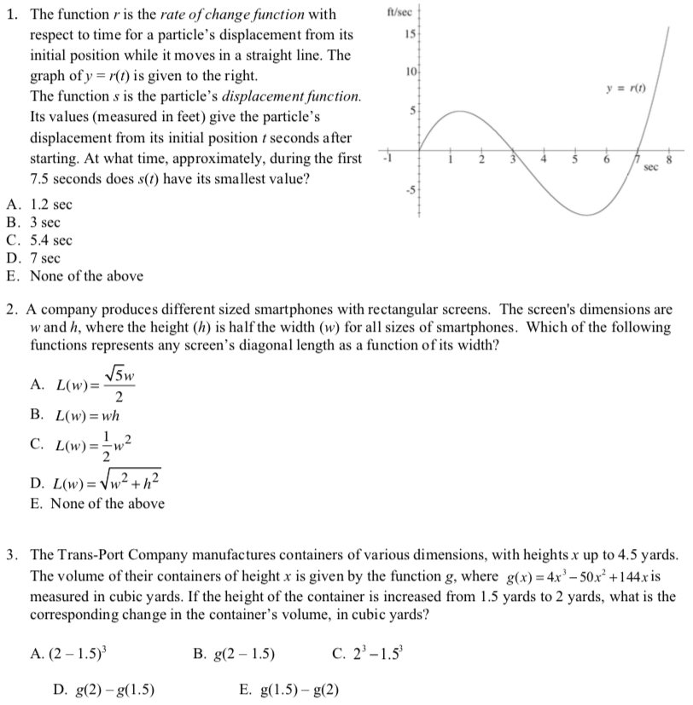
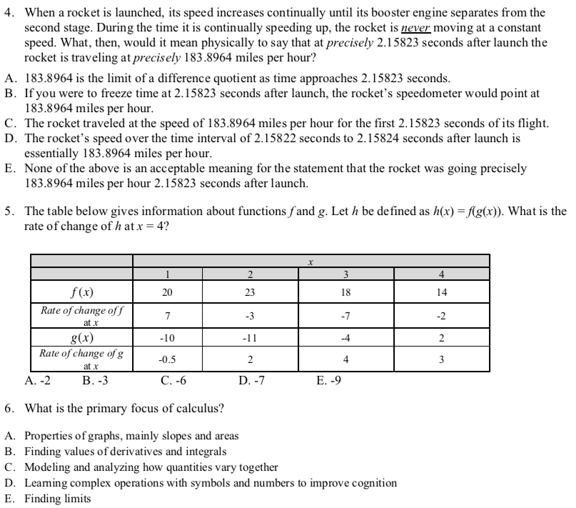
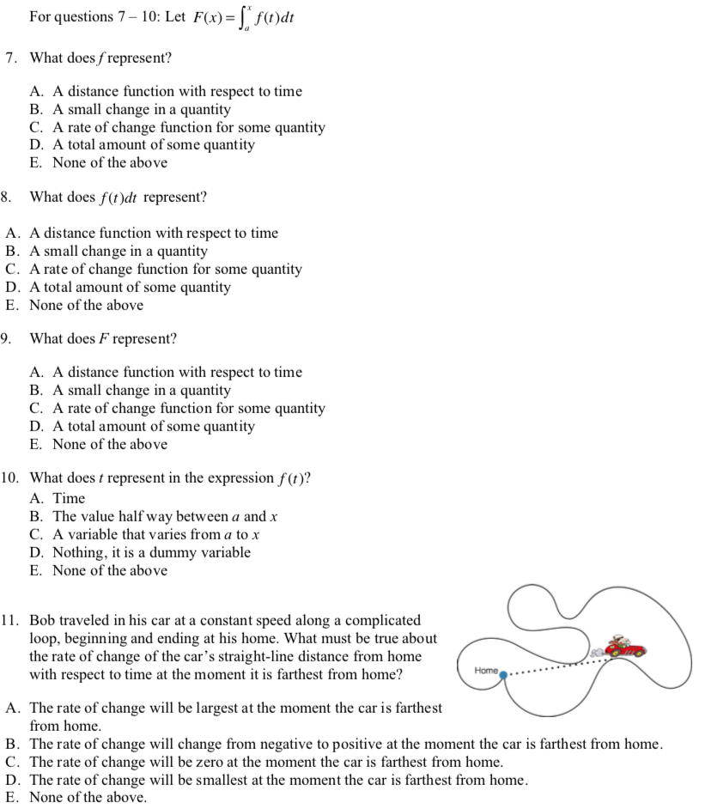

RMC Research Year 1 Report

Pre/Post Test Report
RMC Research reviewed Arizona State University’s 11-item pre- and post-Calculus tests for person fit; item difficulty and technical quality; unidimensionality; and local independence. Using the Rasch measurement model, RMC Research examined the pre-test (n = 1044), the post-test (n = 314), and pre- and post-tests matched by student (n = 278).
Person Fit. RMC Research first analyzed person fit on each pre- and post-test. Misfitting persons represent unexpected or idiosyncratic responses and can bias the estimates of reliability and item difficulty. Person misfit can be attributed to guessing, cultural biases, response sets, or other reasons. Misfitting persons were identified as those having an OUTFIT z-score > 2.0 and were excluded from item diagnostics. Exhibit 1 presents the number of misfitting persons by test.

Exhibit 1. Misfitting Persons by Test

Students | Pre-test | Post-test
All | 55 | 7
Matched Pre- and Post-test | 7 | 6

Summary Statistics. RMC Research examined the person separation, person reliability, item separation, and item reliability for each test. Person separation and reliability reflect the degree to which the test differentiates person ability. In other words, does the test identify low and high ability students? Item separation and reliability reflects the degree to which items range from low to high difficulty. Exhibit 2 presents separation and reliability for persons and items for each test. Results only include non-extreme person and non-extreme items (n = 11).

Exhibit 2. Summary Statistics by Test

Test | n | Person Separation | Person Reliability | Item Separation | Item Reliability
Pre | 960 | .17 | .03 | 6.73 | .98
Post | 299 | 1.19 | .59 | 8.41 | .99
Pre-matched | 268 | .22 | .04 | 7.87 | .98
Post-matched | 265 | 1.16 | .57 | 7,77 | .98
Note. n only includes non-extreme persons. Person separation and item separation reported using the Real RMSE.

Results suggest that measure does distinguish between low and high ability students and that the items range from low to high difficulty. Analyses of the pre-test (for all students assessed and only for those who were matched pre and post) have a relatively low person separation (.17 and .22, respectively) which would be expected for a pre-test. Students have not been exposed Calculus instruction and therefore perform about the same. Person separation increases at post-test (1.19 and 1.16, respectively) which suggests that after students have been exposed to the course, the test identifies a range of student abilities.

Item Difficulty and Technical Quality. RMC Research examined the item difficulty and technical quality through the item-measure correlations and item fit statistics. Exhibit 3 presents item difficulty, and point-measure correlations by pre- and post-test. Items in Exhibit 3 are ordered by easy to difficult to endorse by pre- and post-test condition. Misfitting persons were excluded from these analyses because of their potential to bias estimates.

Exhibit 3. Items Ordered by Easy to Difficult to Endorse

Pre-test |  |  | Post-test |  |  | Matched Pre-test |  |  | Matched Post-test
Item | Measure | Point Meas. Corr. | Item | Measure | Point Meas. Corr. | Item | Measure | Point Meas. Corr. | Item | Measure | Point Meas. Corr.
3 | -2.96 | 0.41 | 3 | -4.02 | 0.42 | 3 | -2.66 | 0.36 | 3 | -4.13 | 0.37
9 | -1.92 | 0.44 | 9 | -0.82 | 0.36 | 6 | -1.72 | 0.33 | 9 | -0.77 | 0.36
6 | -1.17 | 0.36 | 6 | -0.64 | 0.49 | 9 | -1.50 | 0.37 | 6 | -0.67 | 0.45
7 | -1.11 | 0.40 | 7 | -0.37 | 0.52 | 7 | -0.30 | 0.38 | 7 | -0.24 | 0.53
11 | -0.57 | 0.37 | 10 | -0.04 | 0.54 | 10 | -0.30 | 0.38 | 10 | 0.00 | 0.55
10 | -0.51 | 0.37 | 1 | 0.13 | 0.61 | 11 | -0.11 | 0.38 | 1 | 0.10 | 0.59
2 | 0.10 | 0.34 | 11 | 0.25 | 0.50 | 2 | 0.85 | 0.26 | 11 | 0.20 | 0.50
1 | 0.35 | 0.27 | 8 | 0.95 | 0.60 | 1 | 0.92 | 0.36 | 8 | 0.92 | 0.59
4 | 0.80 | 0.18 | 5 | 1.2 | 0.41 | 4 | 1.24 | 0.17 | 5 | 1.23 | 0.41
8 | 1.33 | 0.29 | 2 | 1.54 | 0.39 | 8 | 1.50 | 0.25 | 2 | 1.50 | 0.37
5 | 5.67 | 0.12 | 4 | 1.82 | 0.41 | 5 | 2.09 | 0.30 | 4 | 1.86 | 0.39

Results across all conditions suggest that the items range from easy to difficult to endorse, and the ordering is generally consistent for pre- and post-tests. Items 3, 9, and 6 are consistently easiest to endorse. Items 7, 11, 10, and 1 appear to be mid-range items. Items 2, 4, 5, and 8 appear to be more difficult to endorse.
Structural Validation. There is no evidence that the test violates assumptions of unidimensionality or local independence. RMC Research reviewed the Principal Components Analyses (PCA) for each pre- and post-test to examine unidimensionality and found that the measure explained between 33% and 34% of the variance on the pre-tests and between 34% and 36% of the variance on the post-tests. The PCA identified contrasts for each test (e.g., items that may form another dimension); however, their loadings were not high enough to indicate multidimensionality. RMC Research also examined residual correlations for dependency between pairs of items. No correlations were greater than .70, indicating that the items represent local independence.

C1CI.D1 Report
RMC Research reviewed Arizona State University’s 43-item C1CI test for person fit; item difficulty and technical quality; unidimensionality; and local independence. Using the Rasch measurement model, RMC Research examined the assessment based on 164 exams. The assessment was organized around the seven domains in Exhibit 1.

Exhibit 1. Assessment Domains

Domain | Number of Items
Accumulation | 6
Function | 10
Fundamental Theorem of Calculus | 5
Modeling and Quantitative Reasoning | 3
Rate of Change | 12
Structure Sense | 5
Variables and Constants | 2

Person Fit. RMC Research first analyzed person fit for each domain. Misfitting persons represent unexpected or idiosyncratic responses and can bias the estimates of reliability and item difficulty. Person misfit can be attributed to guessing, cultural biases, response sets, or other reasons. Misfitting persons were identified as those having an OUTFIT z-score > 2.0 and were excluded from item diagnostics. Because Variables and Constants only included two items, it was not included in the analysis. To be considered a scale, a measure needs to include at least three items. Exhibit 2 presents the number of misfitting persons by domain.

Exhibit 2. Misfitting Persons by Domain

Domain | Misfitting Persons
Accumulation | 12
Function | 5
Fundamental Theorem of Calculus | 1
Modeling and Quantitative Reasoning | 7
Rate of Change | 5
Structure Sense | 1
Variables and Constants | N/A

Summary Statistics. RMC Research examined the person separation, person reliability, item separation, and item reliability for each domain. Person separation and reliability reflect the degree to which the test differentiates person ability. In other words, does the test identify low and high ability students?
Item separation and reliability reflect the degree to which items range from low to high difficulty. Exhibit 3 presents separation and reliability for persons and items for each domain. Results include extreme and non-extreme persons and non-extreme items.

Exhibit 3. Summary Statistics by Domain

Domain | n | Person Separation | Person Reliability | Item Separation | Item Reliability
Accumulation | 152 | .61 | .27 | 5.34 | .97
Function | 159 | 1.08 | .54 | 4.21 | .95
Fundamental Theorem of Calculus | 163 | .00 | .00 | 3.15 | .91
Modeling and Quantitative Reasoning | 157 | .40 | .14 | 8.00 | .98
Rate of Change | 159 | 1.06 | .53 | 4.70 | .96
Structure Sense | 163 | .40 | .14 | 3.49 | .92
Variables and Constants | N/A
Note. n includes extreme and non-extreme persons. Person separation and item separation reported using the Real RMSE.

Results suggest that all of the measures, except for the Fundamental Theorem of Calculus, distinguish between low and high ability students. Low person separation and reliability values suggest less variation among students, which would be expected for an end of course exam. Person separation and reliability values of 00., however, suggest that the items do not distinguish among low and high ability students at all. All measures include items that range from low to high difficulty as indicated by high item separation and item reliability values.
Item Difficulty and Technical Quality. RMC Research examined item difficulty and technical quality through the item-measure correlations and item fit statistics. Exhibits 4 through 10 present item difficulty and point-measure correlations for each domain. Items in each exhibit are ordered by easy to difficult to endorse. Misfitting persons were excluded from these analyses because of their potential to bias estimates. Results for all domains indicate that items range from easy to difficult to endorse.
Question 13 and Question 15 were dropped from the analysis due to item misfit, meaning they are not strong indicators of the constructs being measured (Rate of Change and Functions, respectively).
The items in the Accumulation domain range from easy to difficult to endorse and create a 6 -item scale (see Exhibit 4).

Exhibit 4. Accumulation
Items Ordered by Easy to Difficult to Endorse (answer correctly)

Item | Measure | Point Meas.  Corr.
50 | -1.96 | .56
14 | -1.21 | .55
28 | -.59 | .51
34 | -.34 | .49
11 | .52 | .53
36 | 3.57 | .33
The items in the Function domain range from easy to difficult to endorse and create a 9 -item scale. To create a 5-item scale, which would be enough items to measure the construct, consider dropping one item in each of these pairings:
- #42 or #49
- #29 or #21
- #32 or #38
Each of these items measures a very similar concept as indicated by the proximity of their measure values in Exhibit 5.

Exhibit 5. Function
Items Ordered by Easy to Difficult to Endorse (answer correctly)

Item | Measure | Point Meas.  Corr.
27 | -1.70 | .53
42 | -.81 | .59
49 | -.76 | .53
16 | -.18 | .51
37 | .21 | .52
29 | .56 | .51
21 | .64 | .40
32 | .99 | .38
38 | 1.04 | .47

The items in the Fundamental Theorem of Calculus domain range from easy to difficult to endorse and create a 5 -item scale (see Exhibit 6).
Exhibit 6. Fundamental Theorem of Calculus
Items Ordered by Easy to Difficult to Endorse (answer correctly)

Item | Measure | Point Meas.  Corr.
24 | -1.22 | .59
40 | -.44 | .54
31 | .46 | .51
19 | .56 | .40
10 | .63 | .46
The items in the Modeling and Quantitative Reasoning domain range from easy to difficult to endorse and create a 3 -item scale. RMC Research suggests piloting an additional 4 to 6 items with the goal of having a 5 to 7 item scale. The new items could be analyzed along with the 3 items in Exhibit 7 to determine which are the best fit.

Exhibit 7. Modeling and Quantitative Reasoning
Items Ordered by Easy to Difficult to Endorse (answer correctly)

Item | Measure | Point Meas.  Corr.
48 | -3.11 | .73
44 | .08 | .72
26 | 3.03 | .56

The items in the Rate of Change domain range from easy to difficult to endorse and create an 11 -item scale. To create a 5 to 7 item scale, which would be enough items to measure the construct, consider dropping one item in each of these pairings:
- #18 or #23
- #35 or #45
- #41 or #43
- #47 or #22
Each of these items measures a very similar concept as indicated by the proximity of their measure values in Exhibit 8.

Exhibit 8. Rate of Change
Items Ordered by Easy to Difficult to Endorse (answer correctly)

Item | Measure | Point Meas.  Corr.
18 | -1.55 | .55
23 | -1.41 | .50
35 | -.90 | .52
45 | -.77 | .51
17 | -.33 | .40
41 | .00 | .44
43 | .04 | .51
9 | .87 | .40
51 | 1.11 | .39
47 | 1.43 | .33
22 | 1.51 | .28
The items in the Structure Sense domain range from easy to difficult to endorse and create a 5 -item scale (see Exhibit 9).

Exhibit 9. Structure Sense
Items Ordered by Easy to Difficult to Endorse (answer correctly)

Item | Measure | Point Meas.  Corr.
46 | -1.25 | .55
33 | -.18 | .48
12 | .16 | .45
25 | .45 | .59
30 | .82 | .48

Structural Validation. There is no evidence that any of the domains violate assumptions of unidimensionality or local independence. RMC Research reviewed the Principal Components Analyses (PCA) for each domain to examine unidimensionality and found that the measures explained between 22% and 36% of the variance. The PCA identified contrasts for each domain (e.g., items that may form another dimension); however, their loadings were not high enough to indicate multidimensionality.
RMC Research also examined residual correlations for dependency between pairs of items. No correlations were greater than .70, indicating that the items in each domain represent local independence.

Sample Calculus 1 Concept Inventory Items
All items © 2018 Arizona Board of Regents

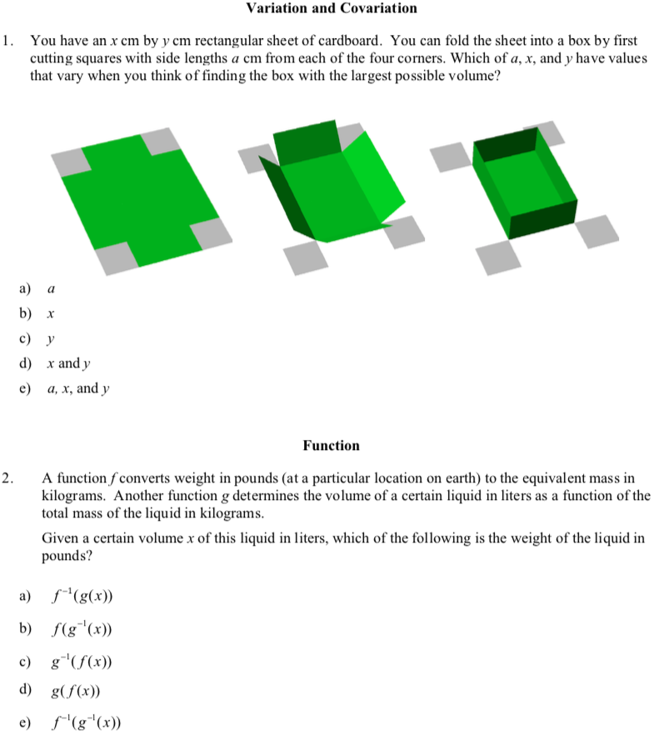
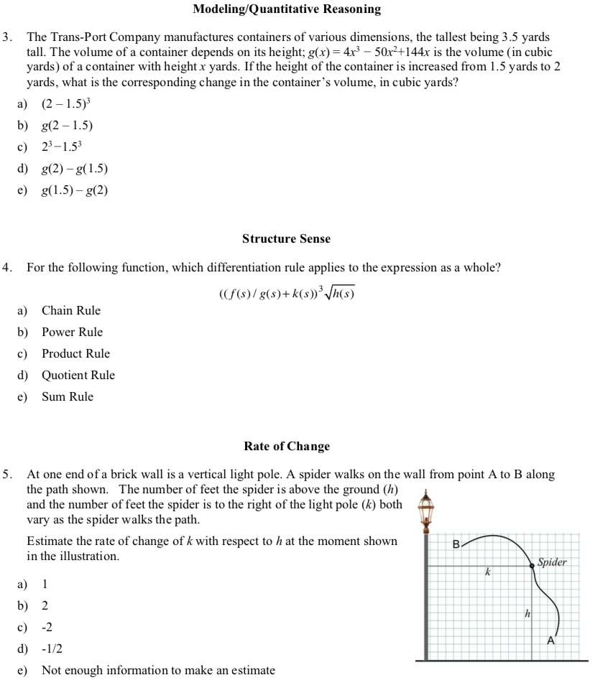
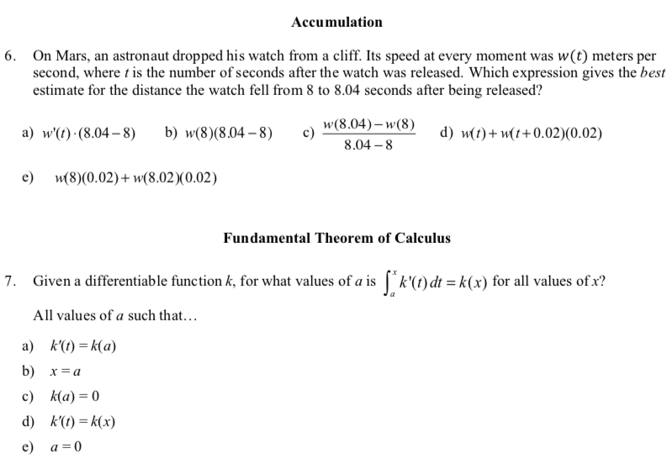

RMC Research Year 2 Report
RMC Research reviewed Arizona State University’s 43-item revised C1CI test for person fit; item difficulty and technical quality; unidimensionality; and local independence. Using the Rasch measurement model, RMC Research examined the assessment based on 237 exams. The assessment was organized around the seven domains in Exhibit 1.

Exhibit 1. Assessment Domains

Domain | Number of Items
Accumulation | 6
Function | 9
Fundamental Theorem of Calculus | 5
Modeling and Quantitative Reasoning | 5
Rate of Change | 8
Structure Sense | 6
Variables and Constants | 4

Person Fit. RMC Research first analyzed person fit for each domain. Misfitting persons represent unexpected or idiosyncratic responses and can bias the estimates of reliability and item difficulty. Person misfit can be attributed to guessing, cultural biases, response sets, or other reasons. Misfitting persons were identified as those having an OUTFIT z-score > 2.0 and were excluded from item diagnostics. Exhibit 2 presents the number of misfitting persons by domain.

Exhibit 2. Misfitting Persons by Domain

Domain | Misfitting Persons
Accumulation | 8
Function | 10
Fundamental Theorem of Calculus | 0
Modeling and Quantitative Reasoning | 13
Rate of Change | 38
Structure Sense | 0
Variables and Constants | 6

Summary Statistics. RMC Research examined the person separation, person reliability, item separation, and item reliability for each domain. Person separation and reliability reflect the degree to which the test differentiates person ability. In other words, does the test identify low and high ability students?
Item separation and reliability reflect the degree to which items range from low to high difficulty. Exhibit 3 presents separation and reliability for persons and items for each domain. Results include extreme and non-extreme persons and items.

Exhibit 3. Summary Statistics by Domain

Domain | n | Person Separation | Person Reliability | Item Separation | Item Reliability
Accumulation | 229 | .86 | .42 | 8.06 | .98
Function | 227 | .94 | .47 | 5.07 | .96
Fundamental Theorem of Calculus | 237 | .28 | .07 | 1.60 | .72
Modeling and Quantitative Reasoning | 224 | .00 | .00 | 2.11 | .82
Rate of Change | 199 | 1.13 | .56 | 9.00 | .99
Structure Sense | 237 | .73 | .35 | 3.13 | .91
Variables and Constants | 231 | .26 | .06 | 3.55 | .93
Note. n includes extreme and non-extreme persons. Person separation and item separation reported using the Real RMSE.
Results suggest that all measures, except Modeling and Quantitative Reasoning, distinguish between low and high ability students. Low person separation and reliability values suggest less variation among students, which would be expected for an end of course exam. Person separation and reliability values of .00, however, suggest that the items do not distinguish among low and high ability students at all. All measures include items that range from low to high difficulty as indicated by high item separation and item reliability values.
Item Difficulty and Technical Quality. RMC Research examined item difficulty and technical quality through the item-measure correlations and item fit statistics. Exhibits 4 through 10 present item difficulty and point-measure correlations for each domain. Items in each exhibit are ordered from easy to difficult to endorse. Misfitting persons were excluded from these analyses because of their potential to bias estimates. Results for all domains indicate that items range from easy to difficult to endorse.
Questions 13, 15, 17, 26, 28, 33, and 35 were dropped from the analysis due to item misfit, meaning they are not strong indicators of the constructs being measured (Function, Modeling and Quantitative Reasoning, and Rate of Change). Each of these items needs to be further examined to assess possible reasons for misfit.
The items in the Accumulation domain range from easy to difficult to endorse and create a 6-item scale (see Exhibit 4).
Exhibit 4. Accumulation
Items Ordered by Easy to Difficult to Endorse: (answer correctly)

Item | Measure | Point Meas.  Corr.
39 | -2.25 | .62
40 | -1.64 | .52
41 | -.61 | .59
42 | .06 | .60
44 | 1.82 | .39
43 | 2.62 | .55
The items in the Function domain range from easy to difficult to endorse and create a 6-item scale as shown in Exhibit 5.

Exhibit 5. Function
Items Ordered by Easy to Difficult to Endorse: (answer correctly)

Item | Measure | Point Meas. Corr.
11 | -1.47 | .63
19 | -.62 | .57
12 | -.17 | .55
16 | .31 | .56
14 | .45 | .59
18 | 1.50 | .65
The items in the Fundamental Theorem of Calculus domain range from easy to difficult to endorse and create a 5-item scale (see Exhibit 6).
Exhibit 6. Fundamental Theorem of Calculus
Items Ordered by Easy to Difficult to Endorse: (answer correctly)

Item | Measure | Point Meas.  Corr.
46 | -.39 | .52
45 | -.27 | .57
49 | .05 | .52
47 | .10 | .58
48 | .51 | .48
The items in the Modeling and Quantitative Reasoning domain range from easy to difficult to endorse; however, RMC suggests a closer review of each of these items because only items 29 and 30 generated item fit statistics (see Exhibit 7). Question 27 may not have generated fit statistics because it appeared to be an extremely easy item. Note that Question 27 was also the easiest item for participants to endorse during the Spring 2017 administration.

Exhibit 7. Modeling and Quantitative Reasoning
Items Ordered by Easy to Difficult to Endorse: (answer correctly)

Item | Measure | Point Meas.Corr.
29 | -.66 | .84
30 | .66 | .80

The items in the Rate of Change domain range from easy to difficult to endorse and create a 6-item scale as shown in Exhibit 8.
Exhibit 8. Rate of Change
Items Ordered by Easy to Difficult to Endorse: (answer correctly)

Item | Measure | Point Meas. Corr.
31 | -2.96 | .64
36 | -2.34 | .65
34 | -2.06 | .66
32 | .92 | .62
37 | 2.86 | .55
38 | 3.58 | .50
The items in the Structure Sense domain range from easy to difficult to endorse and create a 6-item scale (see Exhibit 9).
Exhibit 9. Structure Sense
Items Ordered by Easy to Difficult to Endorse: (answer correctly)

Item | Measure | Point Meas. Corr.
20 | -.57 | .43
23 | -.49 | .54
25 | -.39 | .54
21 | .15 | .54
22 | .41 | .53
24 | .88 | .59
The items in the Structure Sense domain range from easy to difficult to endorse and create a 6-item scale (see Exhibit 10).

Exhibit 10. Variables and Constants
Items Ordered by Easy to Difficult to Endorse: (answer correctly)

Item | Measure | Point Meas.  Corr.
7 | -.72 | .49
8 | -.50 | .64
9 | .45 | .57
10 | .77 | .49

Structural Validation. There is no evidence that any of the domains violate assumptions of unidimensionality or local independence. RMC Research reviewed the Principal Components Analyses (PCA) for each domain to examine unidimensionality and found that the measures explained between 10% and 56% of the variance. The PCA identified contrasts for each domain (e.g., items that may form another dimension); however, the loadings were not high enough to indicate multidimensionality. RMC Research also examined residual correlations for dependency between pairs of items. No correlations were greater than .70, indicating that the items in each domain represent local independence.

Sample Calculus 2 Concept Inventory Items
Geometric Applications
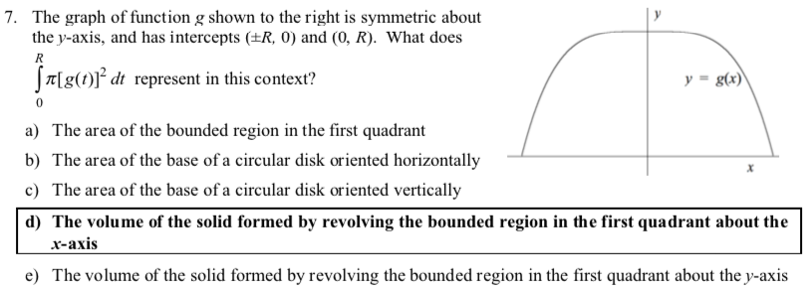
Integration Techniques
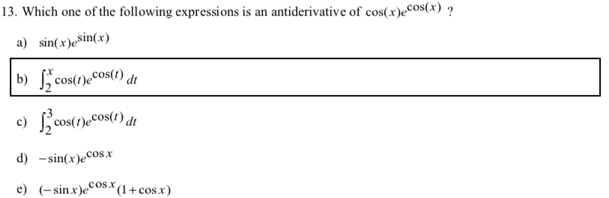
Parametric Functions
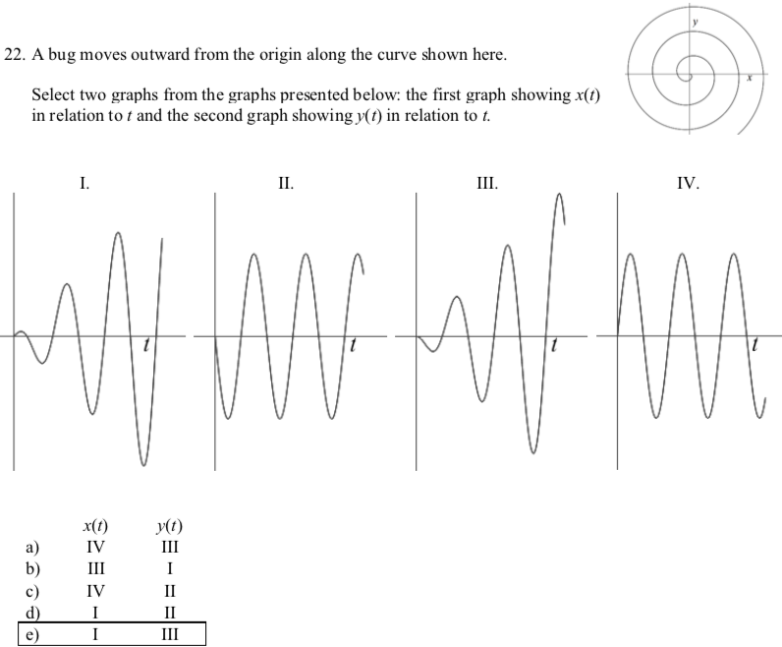
Physical Applications
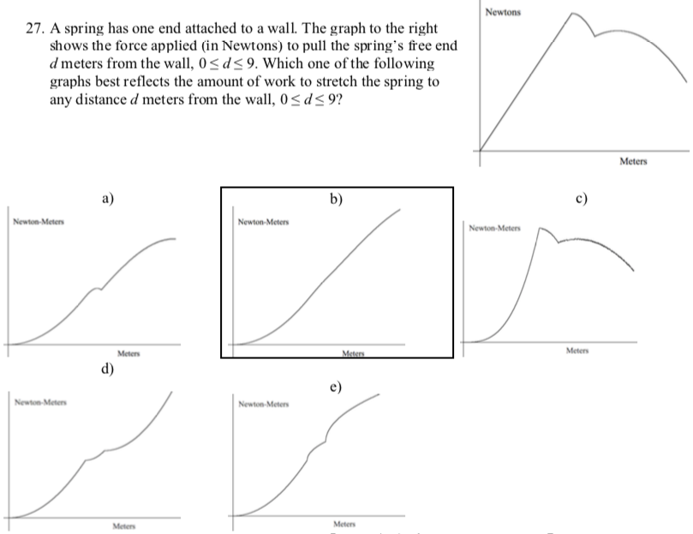
Polar Coordinates
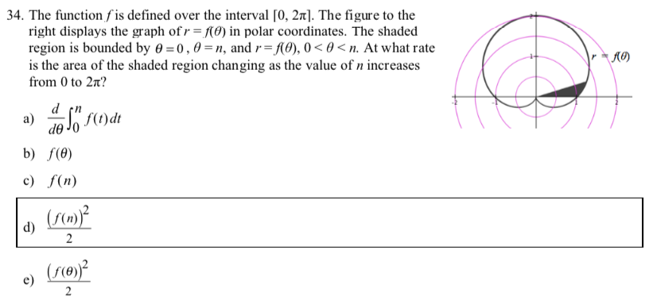

RMC Research Year 3 Report
RMC Research reviewed Arizona State University’s 40-item C2CI test for person fit; item difficulty and technical quality; unidimensionality; and local independence. Using the Rasch measurement model, RMC Research examined the assessment based on 254 exams. The assessment was organized around the seven domains in Exhibit 1.
Exhibit 1. Assessment Domains
Domain | Number of Items
Geometry | 6
Integration Techniques | 8
Parametric Functions | 5
Physical Applications | 7
Polar Coordinates | 7
Sequence and Series | 7

Person Fit. RMC Research first analyzed person fit for each domain. Misfitting persons represent unexpected or idiosyncratic responses and can bias the estimates of reliability and item difficulty. Person misfit can be attributed to guessing, cultural biases, response sets, or other reasons. Misfitting persons were identified as those having an OUTFIT z-score > 2.0 and were excluded from item diagnostics. Exhibit 2 presents the number of misfitting persons by domain.
Exhibit 2. Misfitting Persons by Domain
Domain | Misfitting Persons
Geometry | 9
Integration Techniques | 3
Parametric Functions | 18
Physical Applications | 2
Polar Coordinates | 29
Sequence and Series | 2
Summary Statistics. RMC Research examined the person separation, person reliability, item separation, and item reliability for each domain. Person separation and reliability reflect the degree to which the test differentiates person ability. In other words, does the test identify low and high ability students? Item separation and reliability reflect the degree to which items range from low to high difficulty. Exhibit 3 presents separation and reliability for persons and items for each domain. Results include extreme and non-extreme persons and non-extreme items.
Exhibit 3. Summary Statistics by Domain
Domain | n | Person Separation | Person Reliability | Item Separation | Item Reliability
Geometry | 245 | .46 | .17 | 6.49 | .98
Integration Techniques | 251 | .72 | .34 | 5.00 | .96
Parametric Functions | 236 | .54 | .22 | 7.18 | .98
Physical Applications | 252 | .00 | .00 | 3.19 | .91
Polar Coordinates | 225 | .00 | .00 | 2.67 | .88
Sequence and Series | 252 | .23 | .05 | 5.23 | .96
Note. n includes extreme and non-extreme persons. Person separation and item separation reported using the Model RMSE.
Results suggest that all measures except Physical Applications and Polar Coordinates distinguish between low and high ability students. Low person separation and reliability values suggest less variation among students, which would be expected for an end of course exam. Person separation and reliability values of .00, however, suggest that the items do not distinguish among low and high ability students at all. All measures include items that range from low to high difficulty as indicated by high item separation and item reliability values. Physical Applications items continued to be difficult for most students. Polar Coordinates had three items that fit the model; item 34, 36, and 38 were misfitting and item 35 may have been too easy.
Item Difficulty and Technical Quality. RMC Research examined item difficulty and technical quality through the item-measure correlations and item fit statistics. Exhibits 4 through 9 present item difficulty and point-measure correlations for each domain. Items in each exhibit are ordered from easy to difficult to endorse. Misfitting persons were excluded from these analyses because of their potential to bias estimates. Results for all domains indicate that items range from easy to difficult to endorse (answer correctly).
The items in the Geometry domain range from easy to difficult to endorse and create a 6-item scale (see Exhibit 4).
Exhibit 4. Geometry
Items Ordered by Easy to Difficult to Endorse (answer correctly)
Item | Measure | Point Meas. Corr.
6 | -2.16 | .54
7 | -1.20 | .60
8 | -.47 | .52
11 | .24 | .37
9 | .46 | .43
10 | 3.13 | .46

The items in the Integration Techniques domain range from easy to difficult to endorse and create an 8-item scale (see Exhibit 5).
Exhibit 5. Integration Techniques
Items Ordered by Easy to Difficult to Endorse (answer correctly)
Item | Measure | Point Meas. Corr.
17 | -1.45 | .54
14 | -.82 | .45
12 | -.38 | .42
16 | -.05 | .46
18 | .07 | .42
13 | .53 | .44
15 | 1.02 | .36
19 | 1.09 | .39
The items in the Parametric Functions domain range from easy to difficult to endorse and create a 5-item scale (see Exhibit 6).
Exhibit 6. Parametric Functions
Items Ordered by Easy to Difficult to Endorse (answer correctly)
Item | Measure | Point Meas. Corr.
22 | -2.15 | .66
21 | -.24 | .55
23 | -.21 | .49
20 | .07 | .52
24 | 2.53 | .40
The items in the Physical Applications domain range from easy to difficult to endorse and create a 7-item scale as shown in Exhibit 7.
Exhibit 7. Physical Applications
Items Ordered by Easy to Difficult to Endorse (answer correctly)
Item | Measure | Point Meas. Corr.
29 | -1.11 | .45
31 | -.14 | .46
25 | -.11 | .43
30 | .01 | .46
28 | .04 | .37
26 | .65 | .39
27 | .65 | .30
The items in the Polar Coordinates domain range from easy to difficult to endorse and create a 3-item scale (see Exhibit 8).
Exhibit 8. Polar Coordinates
Items Ordered by Easy to Difficult to Endorse (answer correctly)
Item | Measure | Point Meas. Corr.
33 | -.75 | .65
37 | .13 | .69
32 | .62 | .66

The items in the Sequence and Series domain range from easy to difficult to endorse and create a 7-item scale (see Exhibit 9).
Exhibit 9. Sequence and Series
Items Ordered by Easy to Difficult to Endorse (answer correctly)
Item | Measure | Point Meas. Corr.
39 | -1.25 | .47
41 | -1.15 | .48
43 | -.55 | .46
42 | .41 | .36
45 | .41 | .38
40 | .88 | .38
44 | 1.25 | .28

Structural Validation. There is no evidence that any of the domains violate assumptions of unidimensionality or local independence. RMC Research reviewed the Principal Components Analyses (PCA) for each domain to examine unidimensionality and found that the measures explained between 16% and 34% of the variance. The PCA identified contrasts for each domain (e.g., items that may form another dimension); however, the loadings were not high enough to indicate multidimensionality. RMC Research also examined residual correlations for dependency between pairs of items. No correlations were greater than .70, indicating that the items in each domain represent local independence.

DIRACC Calculus 1 Reading Survey (Online)

These Questions Are About Your Prior Mathematics Courses in School or College
Q1: Prior to this course I had calculus
-In high school
-In college using a textbook other than the online textbook for my current course
-In college using the the same online textbook I am using for my current course
-Never before

Q2: In previous math classes, I succeeded by memorizing procedures.
Strongly Agree
Somewhat Agree
Neither Agree nor Disagree
Somewhat Disagree
Strongly Disagree
I don’t know

Q3a: In previous math classes, I succeeded by making connections among ideas.
Strongly Agree
Somewhat Agree
Neither Agree nor Disagree
Somewhat Disagree
Strongly Disagree
I don’t know

Q3b: What does “making connections among ideas” mean to you?

Q4: In my previous math classes, I read the body (not just exercises) of the textbook

 | Never | Rarely | Sometimes | Often
when readings were assigned
when readings were not assigned
to find examples similar to homework
to preview material before attending class
after class to understand the material covered during class

Q5: In my previous math classes, I studied for exams by _________ in the textbook.

 | Never | Rarely | Sometimes | Often
looking for solved examples
reading explanations of concepts
completing the chapter review
reviewing definitions of key terms
working unassigned problems
reworking assigned problems

Q6 : When your mathematics instructor made a reading assignment, I (select up to two typical actions)
- My prior instructors did not assign readings
- Rarely or never read the textbook
- Skim for keywords in bold and key ideas in boxes
- look for examples that resemble the homework problems
- Read every sentence carefully
- Take notes about key ideas while reading

Q7a: I read the textbook ________ material is presented in class.
before
after
both before and after
neither before nor after

Q7b: Please explain your answer to Q7.

Q8a: Reading a mathematics textbook is different than reading other kinds of textbooks.
Strongly Agree
Somewhat Agree
Neither Agree or Disagree
Somewhat Disagree
Strongly Disagree

Q8b: Explain why you selected your answer.

Interview 2 Protocol

Note for the interviewer: Below is the structure of the interview and then each passage with specific questions for meanings related to the passage. If something is not clear, then please comment on it so that we may fix it. We will be using this structure for all interviews moving forward unless we decide after the first round that modifications need to be made. Descriptions of how we will ask about animations and activities at the end of the structure section.

Notes in red are specific to researcher actions, in blue are student actions, in black are additional notes.

Please remember that this is a guideline and if you have an opportunity to ask about their meanings in the moment then please do so.
Structure of Interview:
- Casual conversation
- Read first passage
- Ask about behaviors
- Ask about meanings
- Repeat steps 2-4 with passages 2,3,4,5

1) Open with casual conversation:
-Find out about how they feel about the course since the last interview.
-Ask if their reading habits/textbook use has changed.
-Ask if their feelings about the textbook have changed.
  - How are you feeling about your math class?
  - Have your reading habits changed since the last interview?

2) Instructions to the student for reading passages:
Tell students:
-We are interested in how you are understanding these passages.
-This will not affect your grade in the course.
-To explain their thinking as much as possible.
-To read out loud and think out loud, stopping wherever they need to explain what they just read.
-It is ok to reread something.
-We may ask clarifying questions throughout the interview.
-There is no right or wrong answers- we just want to know what they are thinking.

Student reads first passage (4.9).
-Take careful mental notes about the student’s behavior and meanings expressed while reading.
-If student pauses to think silently, ask the student to express why they paused/what they are thinking about.
- Skipping sentences/words/mathematical terms /animations/activities
- Rereading
- Reading straight though
- Talking through their understandings as they read
- Creating examples or non-examples related to the concept
- Making connections with other passages, within a passage
- Making connections between the animations and the text.

3) Behaviors:
Ask about certain behaviors that were observed during the interview.
- “That Thing”
-Skipping sentences/words/mathematical terms /animations/activities
-Rereading
-Reading straight though
-Talking through their understanding as they read
-Creating examples or non-examples related to the concept
-Making connections with other passages, within a passage
-Making connections between the animations and the text.
- “I noticed you said “that thing”, what did you mean when you said “that thing”?
- “I noticed you skipped the reflection question, what was your reason for skipping it?”
- “I noticed you reread this sentence several times, what you were thinking while you were rereading it?”
- “I noticed you actively tried to make connections to the passage you were reading and lecture/recitation, is this something you do often?”

If the student played the animation and did not imagine what they might see.
Ask about why the student did not imagine what they might see in the animation
- “Before watching the animation, you had said you do not imagine what you might see in the animation, why not?”
If the student did not play the animation.
Ask about why the student skipped the animation.

4) Meanings:
Ask students to explain the big idea of the passage.
Questions for meanings will vary for each passage. See questions in the passages below.
At the end of each meanings passage if the student played the animation on their own the researcher should ask if not conveyed:
- “When you played the animation did you try to relate it to the passage you just read?”
- “In what ways do you think the animation is related to the passage you just read?”

5)
Student reads second passage (5.1.a).
Repeat the above structure.
Student reads third passage (5.2.3).
Repeat the above structure.
Student reads fourth passage (5.4 animation).
Repeat the above structure.

Instructions for animations:

Option 1: Student plays animation on their own and does not verbalize that they are imagining anything before it plays.
After the student presses play ask student to pause and ask
“Before continuing to watch the animation did you imagine what you might see in the animation while reading text?”
If student responds yes, what are you imagining?
If student responds no, ask about at the end of behaviors (see behavior section)?
Option 2: The student does not play the animation.
- Ask students why they skipped the animation at the end of behavior section.
- Ask students to play the animation at the end of the meanings section. (“Go back to the part of text-now this time I would like you to read this, and from what your reading I want you to try to imagine what you might see in the animation.” Play the animation.)
- “When you played the animation did you try to relate it to the passage you just read?”
- “In what ways do you think the animation is related to the passage you just read?”

Instructions for activities (GC included):
Option 1: Student participates in the activity on their own and does not verbalize that they are imagining anything before beginning.
After the student clicks the link to the animation ask student to pause and ask
“Before continuing the activity did you imagine what you might see in the activity while reading text?”
If student responds yes, what are you imagining?
If student responds no, ask about at the end of behaviors (see behavior section)?
Option 2: The student does not click the link for the activity.
- Ask students why they skipped the activity at the end of behavior section.
- Ask students to participate in the activity at the end of the meanings section. (“Go back to the part of text-now this time I would like you to read this, and from what your reading I want you to try to imagine what you might see in the animation.” Click the activity.)
- “When you did the activity did you try to relate it to the passage you just read?”
- “In what ways do you think the activity is related to the passage you just read?”

Passages and Related Questions

The passages below include the following topics: The meaning of Essentially equal to, approximate accumulation function, approximate net accumulation function, approximate rate of change from exact accumulation functions.

Questions before passages related to beliefs:
- Find out about how they feel about the course since the last interview.
-Ask if their reading habits/textbook use has changed.
-Ask if their feelings about the textbook have changed.

Questions before passages related to content:
Variation – What is the difference between dx and ∆x? Can you recall the moment when you made the distinction between the two?
Rate of change -
- What is the rate of change at a moment?
- What is a moment? (Only if clarification is needed.)
- Does every moment on a function have a rate of change?

-Ask students what this means to them now that they have spent the past month on: “You know how fast a quantity varies at every moment; you want to know how much of it there is at every moment.”

First Passage: http://patthompson.net/ThompsonCalc/section_4_9.html

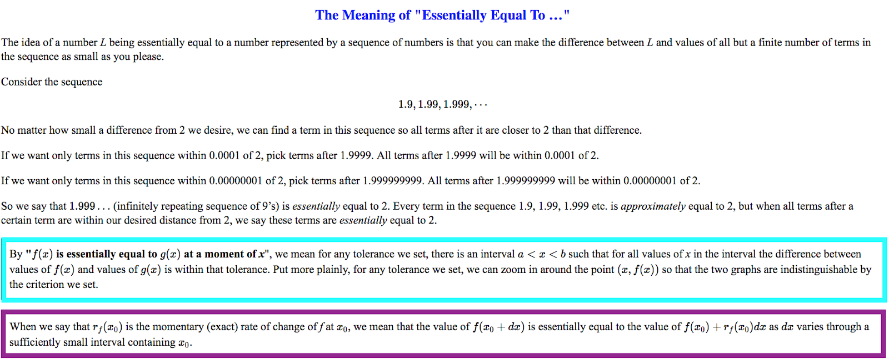
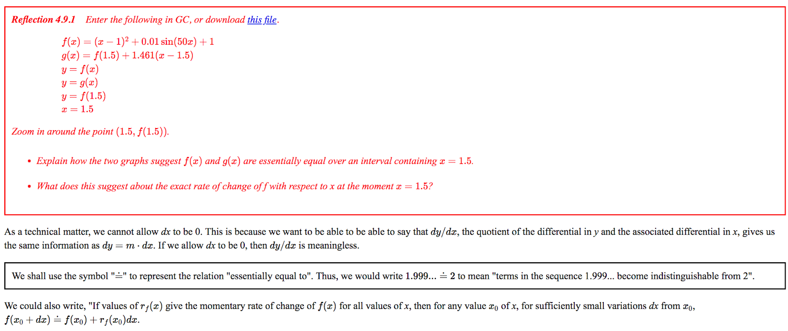

First Passage: Section 4.9 Exact ROC Functions – The Meaning of “Essentially Equal to. (screenshot above) | Before passage - We want to know students’ meanings for  - ROC functions (exact and approximate)  - Their meanings for essentially equal to  “Have you seen this passage before?”  “What do you remember from it?”  “Have you discussed this topic in recitation or lecture?”  From lecture? Recitation? The book?  Related to ROC  -What does an “Exact ROC function mean to you?”  -What does an approximate ROC function mean to you?  -How many approximate ROC functions are there for a given exact ROC function.  -Suppose that you make an approximate ROC function from an exact ROC function. How are the two related?  Related to Essentially Equal To  Ask the following to determine if you should have the student skip the passage or not. * on ipad  - What does the statement “The approximate rate of change function is essentially equal the exact rate of change function for sufficiently small ∆x-intervals” mean to you?  -Ask student to use the 4.9 GC file to explain what they have in mind after talking about what the above means to them  (This is for ALL students)  -If students can explain the statement and use the GC file to also explain their thinking in line with the following:  1) they identify ∆x  2) they explain that as ∆x gets small the approx ROC values are close enough to the exact ROC values  then, move on  -If students cannot explain the statement correctly with the GC file- Ask the student to read the section  -What is the difference between essentially equal to and approximately equal to? (We are asking this to all students, regardless if they skip the passage).
 | Student reads passage – be sure to ask about behaviors/meanings in the moment
Boxed in blue  Boxed in purple | After passage –  - Ask about behaviors (see in Protocol structure 3)  - Meanings to ask about:  -Ask students what “By "f(x)is essentially equal to g(x) at a moment of x", we mean ….criterion we set.”  - Ask students what “When we say that rf(x0) is the momentary (exact) rate of change...When we say that rf(x0) is the momentary (exact) rate of change”  - What is the difference between essentially equal to and approximately equal to?  -The title of this section is Exact ROC functions why do you think the author included this passage on the meaning of essentially equal to in this section of the book?  For GC Activity answer the questions

Second Passage: http://patthompson.net/ThompsonCalc/section_5_1.html

Part I -
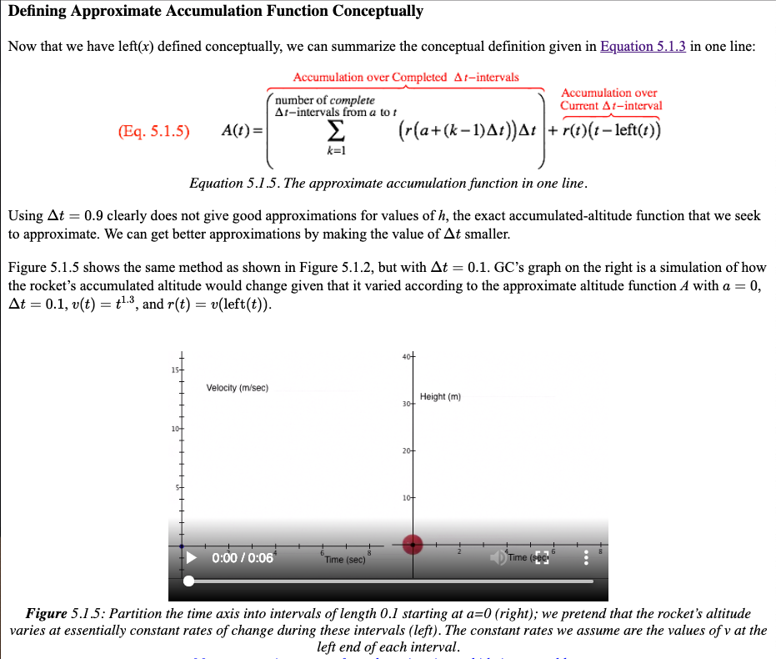
Part II –

Second Passage – Part I: Section 5.1a Defining Approximate Accumulation Function Conceptually (screenshot above) | Before passage - We want to know students’ meanings for  - Accumulation functions (approximate, exact, net, total)  “Have you seen this section before?”  “What do you remember from it?”  “Have you discussed this topic in recitation or lecture?”  Accumulation Function  -What do you anticipate this section “Introduction to Accumulation Function” going to talk about?  Approximate Accumulation Function  - Ask the student to imagine that you are in the same calculus course, but you’ve missed the last month of class for various reasons. Can you explain what an approximate accumulation function is and how we get from an exact rate of change to its approximate accumulation function.  Be sure to let the student know that they can draw if need be.  If students draw a piecewise function similar to 5.1.3 or draw an image described as being linear, ask them why? Or explain their reasoning.  How would you represent the approx accumulation function symbolically or with formula?  Exact Accumulation Function  - Ask the student to imagine that you are in the same calculus course, but you’ve missed the last month of class for various reasons. Can you explain what an exact accumulation function is and how we get exact accumulation from approximate accumulation function.  Be sure to let the student know that they can draw if need be.  How would you represent the exact accumulation function symbolically or with a formula?  Net versus Total Accumulation  - “So, I’ve heard other students use net accumulation and total accumulation, but I don’t know the difference between the two can you explain the difference to me.  Be sure to let the student know that they can draw if need be.  -Ask students about the title of the passage “Defining the approximate accumulation function conceptually”  Ask student what does it mean to define a function conceptually or what do they anticipate the section to discuss.
 | Student reads passage – be sure to ask about behaviors/meanings in the moment
After passage –
- Ask about behaviors (see in Protocol structure 3)
- Meanings to ask about:
- Ask students what they think is the purpose of this animation is in this section?

-Ask students to explain Eq. 5.1.3

- Ask students what Eq. 5.1.5 is describing or what this accumulation function means to them?
-Why is this approximate accumulation function conceptual?

-Ask about the approximate accumulation function:
*Ask students to explain the different parts of the appox accum function
*What is varying in the equation?
*You should ask the student about different parts of the approximate accumulation function if they do not elaborate when first asking. Specifically,
- left(t),
- ∆t,
- a,
- a+(k-1)∆t,
- r(a+(k-1)∆t),
- r(t)(left(t)),
Ask student where they see the following in the animation.
- left(t),
- ∆t,
- a,
- a+(k-1)∆t,
- r(a+(k-1)∆t),
- r(t)(left(t)),
After reading the passage, ask students what the big idea of passage is and how this idea is related to the passage title.

Segue to next passage. | Can the current value of t be in a completed interval of the accumulation function?

Third Passage: http://patthompson.net/ThompsonCalc/section_5_2.html
Part I
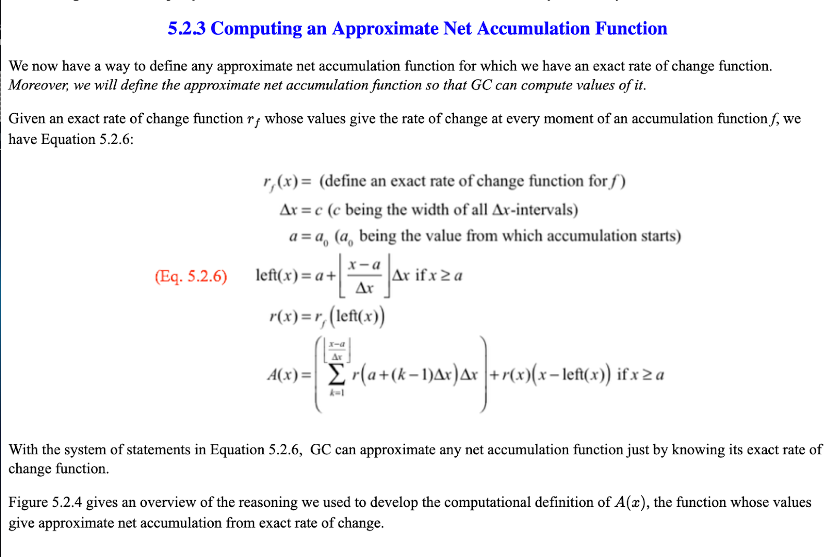

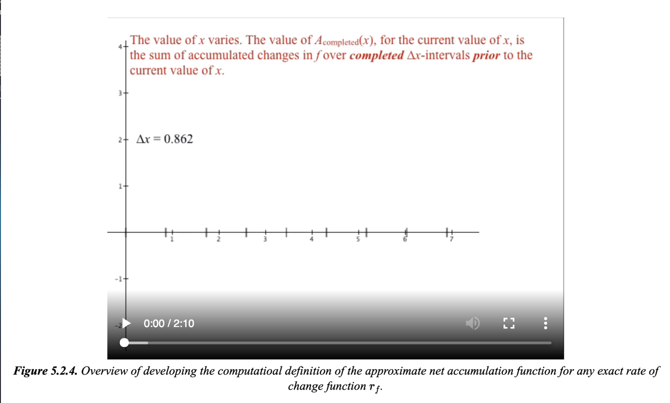
Part I
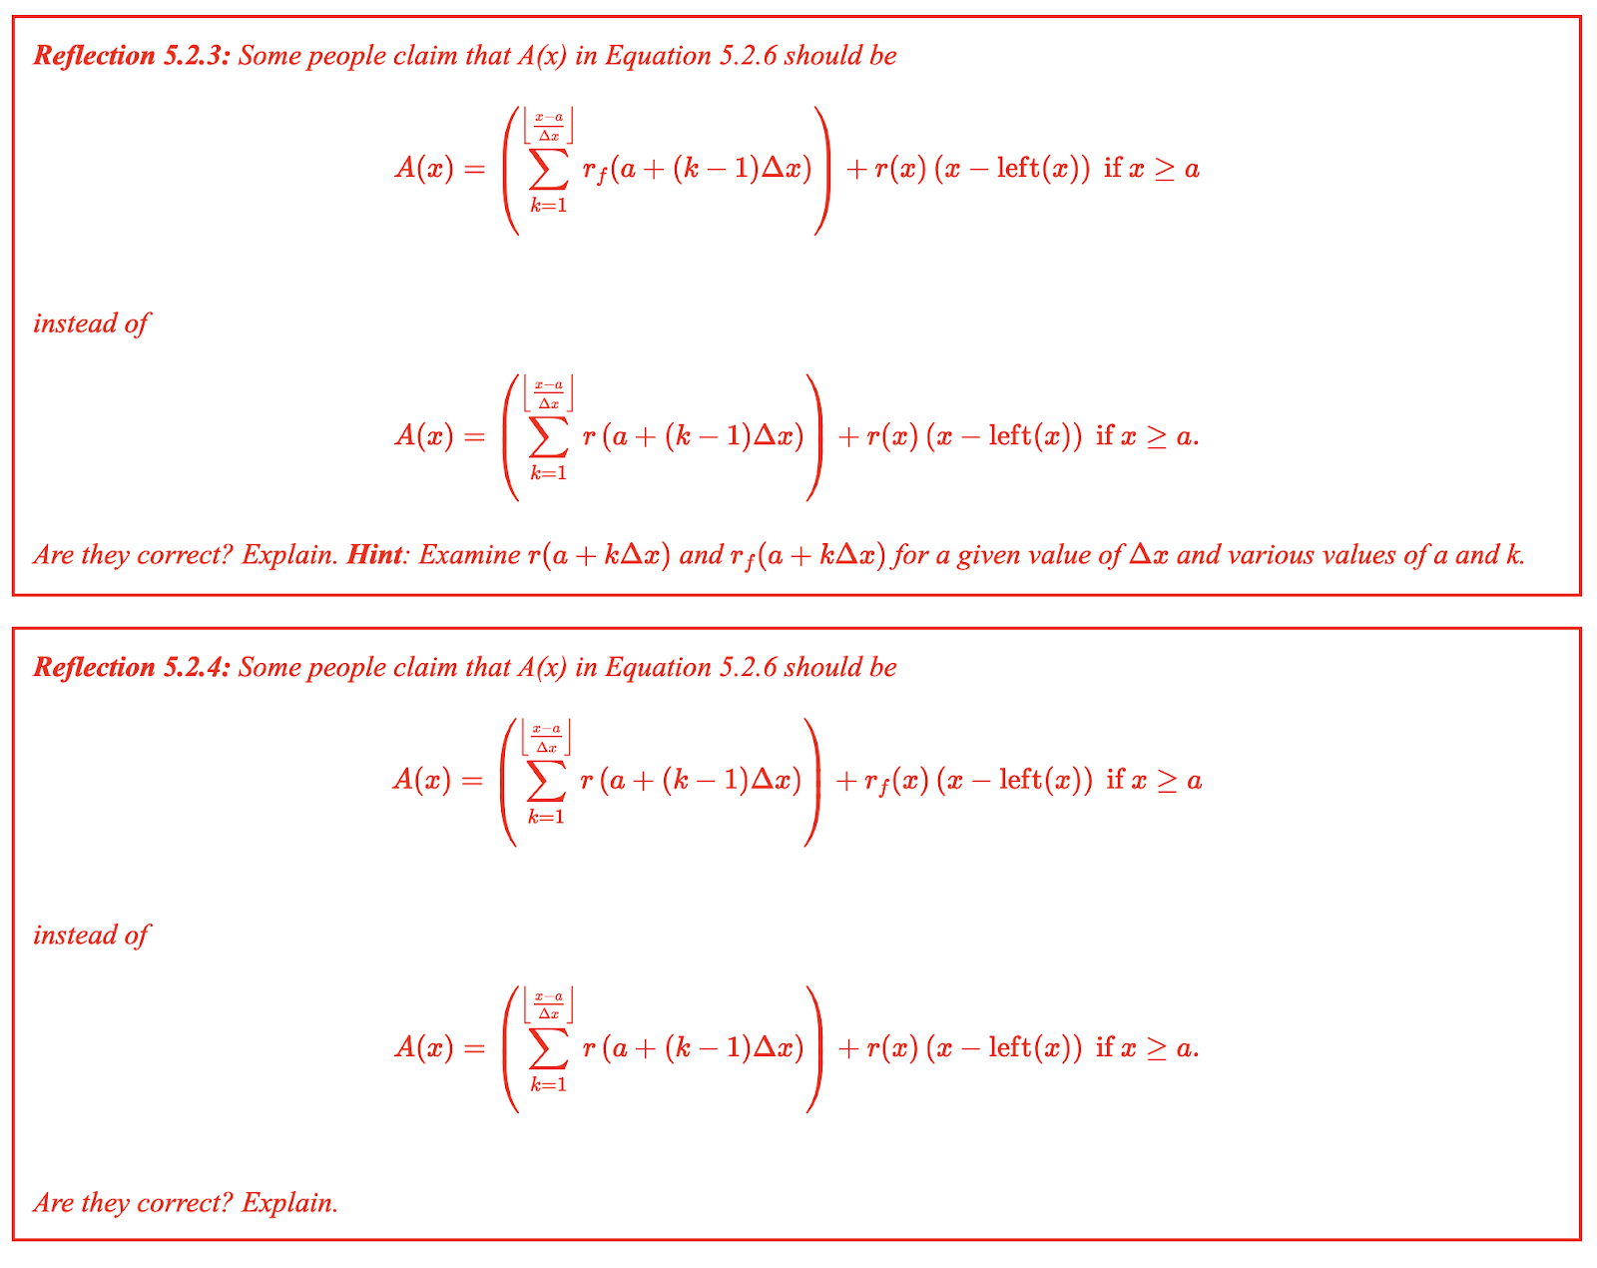

Third Passage – Part I: Section 5.2.3 Computing an Approximate Net Accumulation | Before passage -  -No questions on meanings.  -Why do you think the author titled this section “Computing an Approximate Net Accumulation Function”?  -The last passage was titled “Defining the Approximate Accumulation Function Conceptually.” This passage is titled “Computing an Approximate Net Accumulation.” How does this passage relate to the previous passage?  Be sure to have the passages open on separate tabs.
 | Student reads passage – be sure to ask about behaviors/meanings in the moment
Highlight Eq. 5.2.6 for the student | After passage –  - Ask about behaviors (see in Protocol structure 3)  - Meanings to ask about:  -Ask what dies the title mean to you now that you have read the passage  -Ask how does this section connect to the previously read passage (5.1), now that the student has read through the passage.  -Ask about where the student sees the “computing” in this equation.  Questions related to the animation:  You may not ask them about parts of all of this if they have talked through the animation thoroughly.  -Animation: Pause at time 0:15  Ask student about what is happening at this moment we have paused.  Suggested ideas if the student is having a hard time:  Ask about why the graph has horizontal segments  Pick a point on the graph and ask them what it represents.  If student is not thinking about it as the accumulation from completed intervals and instead thinking about this as ROC point this out to them and ask about a point on the graph again  Why does the value of A_{completed}(x) not change over the  course of a completed interval?  -Animation: Pause at time 0:39  Ask student about what is happening at this moment we have paused.  Suggested ideas if the student is having a hard time:  Ask about why the graph has diagonal segments  Pick a point on the graph and ask them what it represents.  Why does the current accumulation function start at zero at the beginning of each new interval?  -Animation: Play clip between 1:15-1:25  Ask student about what they see in the clip.  Suggested ideas if the student is having a hard time:  Ask about what the brown horizontal segments are.  Pick a point on the blue graph (app. net accumulation) and ask them what it represents.
Third Passage – Part II: Section 5.2.3  (The reflection questions) | 3) Ask about behaviors (see in Protocol structure  4) Meaning to ask about:  -Ask students to answer reflection questions and explain their thinking.

Fourth Passage :http://patthompson.net/ThompsonCalc/section_6_1.html

Animation review Chapter 5.

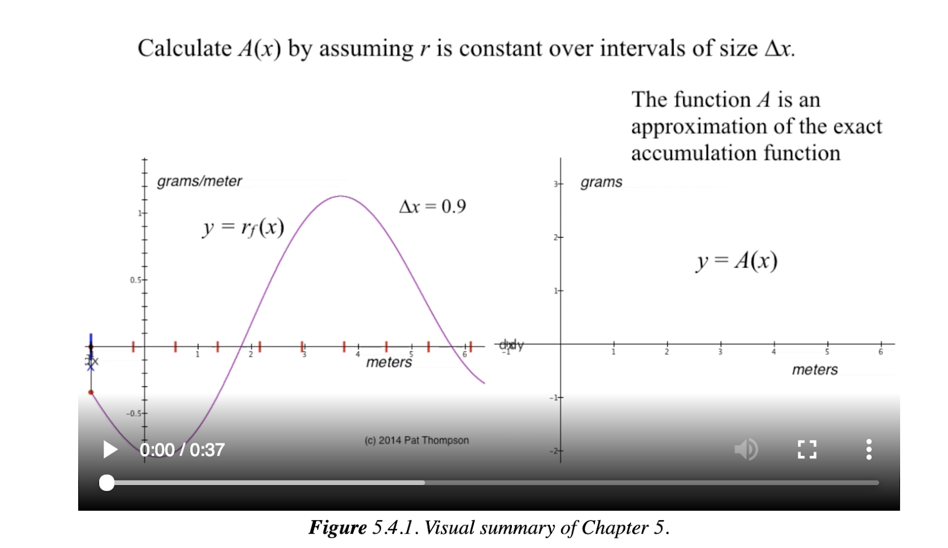
Fourth Passage – Animation, Figure 5.4.1 | -Have student read the figure description  -Ask student to anticipate what they are going to see in the animation  After watching the animation:  -How do you think this animation summarizes Chapter 5

END

The survey contained 30 questions asking about their use of the textbook, their use of GC, and their thoughts on instruction.
In interests of brevity, we will say “many students” without quantifying how many. In manuscripts we quantify the prevalence of these observations. But all themes we describe happened frequently enough to stand out as worth analyzing further.
Questions 7-10 use integral notation. We felt warranted in asking this question on the pretest because 70% of students enrolling in calculus at ASU took calculus in high school.

